
University of Karbala
Collage of Applied Medical science
Department of Clinical Laboratories
Thesis is approved for the master’s degree of Sciences in the …….
Title
Evaluation of the levels of Proteinase-3 (PR3), angiotensin-converting enzyme (ACE) and visfatin as promising indicators for early detection of types the Angina in male in kerbala Province
Supervisors
Dr. Ruqaya Kareem
Advisor
Dr. .....
Researcher
...
Date
2025



Acknowledgement
First and foremost, praises and thanks to the God, the Almighty, for His showers of blessings throughout my research work to complete the research successfully.
I would like to express my deep and sincere gratitude to my research supervisor, Dr. Ruqaya Kareem for giving me the opportunity to do research and providing invaluable guidance throughout this research. I would like to offer my special thanks to Dr. ….. for providing excellent guidance and feedback throughout this project.
I am grateful to Dr. …….. for creating a supportive and stimulating environment for students and faculty in the Clinical Laboratories department. I am proud to be a part of this community."
I would like to thank my friends and family for their love and support throughout this journey. They have been my constant source of strength and inspiration.
Finally, my thanks go to all the people who have supported me to complete the research work directly or indirectly.

Surname: Name:
Thesis Title: Evaluation of the levels of Proteinase-3(PR3),angiotensin-converting enzyme(ACE)and visfatin as promising indicators for early detection of types the Angina in male in kerbala Province
Supervisor: Dr. Ruqaya Kareem Advisor; Dr. ..
Degree: Master of ‌ ‌ ‌ ‌ ‌ ‌ ‌ Field: ‌
University: University of Karbala
Department: Clinical Laboratories
Number of Pages: ‌ ‌ ‌ ‌ ‌ ‌ ‌ ‌ ‌ ‌ ‌ ‌ ‌ ‌ ‌ ‌ Graduation Date: 2025 ‌
Key Words: Proteinase-3 (PR3), Angiotensin-converting enzyme (ACE), Troponin I, Myoglobin, Creatine kinase, 4-Hydroxynonenal (4-HNE), Glutathione Peroxidase (GPX-1), White blood cells (WBC), Lipids and lipoproteins, Oxidative stress, Reactive oxygen species (ROS), Reactive nitrogen species (RNS), Angina pectoris, Stable angina, Unstable angina, Cardiovascular disease (CVD), Atherosclerosis, Biomarkers
Abstract ‌ ‌

Summary
Background
Cardiovascular diseases (CVDs), particularly angina pectoris, remain a leading cause of morbidity and mortality worldwide. Angina, characterized by chest pain due to reduced blood flow to the heart, can be classified into stable and unstable forms, each with distinct clinical implications. Early detection and differentiation of angina types are crucial for effective management. This study focuses on evaluating the levels of Proteinase-3 (PR3), angiotensin-converting enzyme (ACE), and visfatin as potential biomarkers for the early detection of angina in males from Karbala Province, Iraq. These biomarkers are associated with inflammatory processes, vascular injury, and metabolic changes, which are key factors in the pathogenesis of angina. The study also examines oxidative stress markers, lipid profiles, and other biochemical factors to provide a comprehensive understanding of angina's pathophysiology.
Methods
The study was conducted at Imam Hussein Medical City Emergency and Cardiac Surgery Center from October 2024 to January 2025. It included 120 male participants: 90 patients diagnosed with angina (45 stable and 45 unstable) and 30 healthy controls. Blood samples were collected at different time intervals (1, 5, 6, 10, and 12 hours) to measure biomarkers such as PR3, ACE, visfatin, troponin, white blood cells (WBC), glutathione peroxidase-1 (GPX-1), 4-hydroxynonenal (4-HNE), and lipid profiles. Enzyme-Linked Immunosorbent Assay (ELISA) was used to measure biomarker levels, and statistical analyses were performed to compare results between patients and controls, as well as between stable and unstable angina groups.

Results
1. Troponin Levels: Troponin levels were significantly higher in angina patients compared to controls, with a progressive increase over time. Unstable angina patients had higher troponin levels than stable angina patients.
2. Visfatin, ACE, and PR3 Levels: These biomarkers were significantly elevated in angina patients, with higher levels observed in unstable angina. Visfatin and ACE levels increased progressively over time, while PR3 levels showed a slight decrease after an initial rise.
3. Oxidative Stress and Inflammation: WBC and 4-HNE levels were higher in angina patients, indicating increased inflammation and oxidative stress. GPX-1 levels were lower in patients, suggesting reduced antioxidant activity.
4. Lipid Profiles: Total cholesterol (TC), triglycerides (TG), and low-density lipoprotein (LDL) levels were significantly higher in angina patients, with more severe dyslipidemia observed in unstable angina.
5. Correlations: Strong correlations were found between visfatin, ACE, PR3, and troponin levels, indicating their interrelated roles in the pathophysiology of angina.
Conclusion
The study demonstrates that PR3, ACE, and visfatin are significantly elevated in angina patients, particularly in those with unstable angina. These biomarkers, along with troponin, oxidative stress markers, and lipid profiles, can serve as promising indicators for the early detection and differentiation of angina types. The findings suggest that these biomarkers could be integrated into clinical practice to improve the diagnosis and management of angina, potentially leading to better patient outcomes. Further research is recommended to validate these findings in larger and more diverse populations, and to explore the therapeutic implications of modulating these biomarkers.

List of Contents
No. | Content | Page No.
I | Summery | V
II | List of Contents | VII
III | List of Tables | IX
IV | List of Figures | X
V | List of Abbreviations | XII
VI | Recommandations | XIII
Chapter One : Introduction |  | 1
1.1 | Introduction | 2
1.2 | The Study Aims | 7
Chapter Two : Literature Review |  | 8
2.1. | The Heart | 9
2.2. | Definition, Causes, and Epidemiology of Angina Pectoris | 9
2.3. | Symptoms, Causes, and Risk Factors of Angina Pectoris | 10
2.4. | Different Types of Angina | 15
2.4.1. | Stable Angina (Angina Pectoris) | 15
2.4.2. | Unstable Angina | 16
2.4.3. | Variant Angina (Prinzmetal's Angina) | 17
2.4.4. | Microvascular Angina | 18
2.4.5. | Pathophysiology of Different Types of Angina: | 19
2.5. | Biochemical factors | 20
2.5.1. | Troponin Relation with Angina Pectoris | 20
2.5.2. | Triglycerides (TG) Relation with Angina Pectoris | 22
2.5.3. | White Blood Cells (WBCs) relation with Angina Pectoris | 22
2.5.4. | Low-density lipoprotein (LDL) Relation with Angina Pectoris | 23
2.5.5. | Cholestrol Relation with Angina Pectoris | 24
2.6. | Biomarkers | 25
2.7. | Role of adipose tissue in the pathogenesis of cardiovascular disease | 28
2.7.1. | Adipokines roles in heart function | 30
2.7.2. | Visfatin | 33
2.8. | Role of Proteinase-3 (PR3) | 35
2.8.1. | PR3 and Its Role in Cardiovascular Disease | 36
2.9. | Angiotensin-Converting Enzyme (ACE) | 38
2.10. | Research purpose | 41
Chapter Three : Literature Review |  | 42
3. | Materials & Methods | 43
3.1. | Materials and general Equipment’s | 43
3.2. | Study population | 44
3.2.1. | Experimental design and participant | 44
3.3. | Comprehensive Data Collection Through Structured Questionnaires | 46
3.3.1. | Sample Collection | 46
3.4. | Measurements of Biochemical parameters | 47
3.4.1. | Lipid profile levels | 47
3.4.2. | CBC test | 49
3.4.3. | Troponin I test | 50
3.5. | Enzyme-Linked Immunosorbent Assay (ELISA) | 50
3.5.1. | Preparation of Working Solutions: | 52
3.5.2. | Human 4-HNE elisa Assay Procedure | 53
3.5.3. | Human GPx-1 ELISA Assay Procedure | 55
3.5.4. | Human PR 3 ELISA Assay Procedure | 56
3.5.5. | Human ACE ELISA Assay Procedure | 57
3.5.6. | Measurement of Visfatin levels in Human serum | 58
3.6. | Statistical analysis | 61
Chapter Four : Results |  | 62
4. | Results | 63
Chapter Five : Discussion |  | 96
5.1. | The Levels of research biomarkers in patients groups and control group at three different time points. | 97
5.2. | The Comparison between research parameters levels at Each Time Point Separately according to the type of angina. | 98
5.3. | The Comparison between research parameters levels at Each Time Point Separately according to the age . | 99
5.4 | The correlation between research parameters levels at Each Time Point Separately according to the stability groups . | 99
References |  | 100
Appendix |  | 115
Appendix.1 | Appendix.1 | 116
Appendix.2 | Appendix.2 | 117

List of Tables
No. | Table | Page No.
Table 2- 1 | Materials and general Equipment’s Laboratory | 45
Table 3- 2 | Lipid Profile Test Kits | 50
Table 3- 3 | List of ELISA Kits Used in the Study | 54
Table 4-1 | The Comparison between (Troponin h.s) levels in patients and control at three different time points. | 65
Table 4-2 | The Comparison between visfatin ,ACE and PR3levels in patients and control at three different time points | 66
Table 4-3 | The Comparison between WBC,GPX-1 and 4-HNE levels in patients and control. | 67
Table 4-4 | The Comparison between lipid profile levels in patients and their controls. | 67
Table 4-5 | The Comparison of groups at Each Time Point Separately for (Troponin h.s) levels according to the type of angina. | 68
Table 4-6 | The Comparison of visfatin ,ACE and PR3 levels at Each Time Point Separately according to the type of angina | 69
Table 4-7 | The Comparison between WBC,GPX-1and 4-HNE levels according to the type of angina. | 70
Table 4-8 | The Comparison between lipid profile levels according to the type of angina. | 70
Table 4-9 | The Comparison of (Troponin h.s) Over Time Within Each Group according to the type of angina. | 71
Table 4-10 | The Comparison of visfatin ,ACE and PR3 levels Over Time Within Each Group according to the type of angina | 71
Table 4-11 | The Comparison of groups at Each Time Point Separately according to the age groups. | 73
Table 4-12 | The Comparison of groups at Each Time Point Separately according to the age groups. | 74
Table 4-13 | The Comparison of lipid profile at Each Time Point Separately according to the age groups. | 75
Table 4-14 | The Comparison of groups at Each Time Point Separately according to the age groups. | 76
Table 4-15 | Patients Correlation Coefficient Among Parameters According to stability group Status (Stable group) | 86
Table 4-16 | Patients Correlation Coefficient Among Parameters According to stability group Status (Stable group). | 88
Table 4-17 | Patients Correlation Coefficient Among Parameters According to stability group Status (Stable group). | 89
Table 4-18 | Patients Correlation Coefficient Among Parameters According to stability group Status (Unstable group). | 91
Table 4-19 | Patients Correlation Coefficient Among Parameters According to stability group Status (Unstable group). | 93
Table 4-20 | Patients Correlation Coefficient Among Biomarkers According to stability group Status (Unstable group). | 94

List of Figures
No. | Figures | Page No.
Figure 2- 1 | The fundamental structure of the heart includes its chambers, principal blood vessels, and the conduction system, which comprises the sinoatrial node, atrioventricular node, and Purkinje fibers. | 10
Figure 2- 2 | angina pectoris, is a type of chest pain or discomfort stemming from an inadequate oxygen-rich blood supply to the heart muscle | 11
Figure 2- 3 | Angina manifests in various forms, each with distinct characteristics and triggers. | 19
Figure 2- 4. | Biomarkers Type | 28
Figure 2- 5. | Most common body fluids for the measurement of biomarkers are: Circulating biomarkers in different body fluids, including blood, urine, saliva, ascites, cerebrospinal fluid. | 29
Figure 2- 6 | Lean adipose tissue primarily secretes anti-inflammatory adipokines, such as adiponectin, while obesity is associated with elevated production of pro-inflammatory factors. | 33
Figure 2- 7. | Adipokines such as adiponectin, vaspin, lipocalin-2, omentin-1, leptin, and FSTL1 contribute to the development of heart failure | 34
Figure 2- 8 | The role of circulating levels of major adipokines in heart failure. | 35
Figure 2- 9 | Proposed function of PR3 and NE in IC-mediated inflammation | 38
Figure 2- 10 | Factors involved in PR3-ANCA pathogenicity. There are two types of interaction between PR3-ANCA and neutrophils: one includes a link between the PR3-ANCA Fab and mbPR3 exposed at the surface of neutrophils and the other involves a bond between the Fc of PR3-ANCA and FcγR. Pathogenicity of PR3-ANCA depends on many factors including the expression of membrane PR3 on neutrophils, the recognized epitopes, the presence or not of Fc gamma receptor polymorphisms, the subclasses and isotypes of PR3-ANCA, and finally the Fc glycosylation of PR3-ANCA. | 40
Figure 2- 11 | Angiotensin-Converting Enzyme in the Human Heart | 43
Figure 3- 1 | The design of study | 47
Figure 3- 2 | The flowchart of ELISA (13). | 53
Figure 3- 3 | Dilution method | 55
Figure 3- 4 | Typical Standard Curve for PR3 | 59
Figure 3- 5 | Standard Curve of the Human Visfatin concentration. | 62
Figure(4-1) | The Comparison between Troponin level in patients and their controls at three different time points. | 77
Figure(4-2): | The Comparison between Visfatin level in patients and their controls at three different time points | 78
Figure(4-3) | The Comparison between ACE level in patients and their controls at three different time points. | 78
Figure (4-4) | The Comparison between PR3 level in patients and their controls at three different time points. | 79
Figure( 4-5) | The Comparison between WBC in patients and control. | 80
Figure (4-6) | The Comparison between GPX-1 and 4- HNE in patients and their control. | 80
Figure( 4-7) | The Comparison between lipid profile in patients and control | 81
Figure( 4-8) | The Comparison of the Troponin level Over Time Within Each Group according to the stability group. | 82
Figure (4-9) | The Comparison of the Visfatin level Over Time Within Each Group according to the stability group. | 82
Figure( 4-10) | The Comparison of the ACE level Over Time Within Each Group according to the stability group. | 83
Figure( 4-11) | The Comparison of the PR3 level Over Time Within Each Group according to the stability group | 84
Figure (4-12) | The Comparison between lipid profile level according to the stability group | 84

Table of Abbreviations
Abbreviation | Full Term
PR3 | Proteinase-3
ACE | Angiotensin-Converting Enzyme
CVD | Cardiovascular Diseases
ROS | Reactive Oxygen Species
RNS | Reactive Nitrogen Species
4-HNE | 4-Hydroxynonenal
GPX-1 | Glutathione Peroxidase-1
WBC | White Blood Cells
MI | Myocardial Infarction
ELISA | Enzyme-Linked Immunosorbent Assay

Recommendations
Based on the study’s findings, the following recommendations are proposed:
- Clinical Application: Implementing PR3, ACE, and Visfatin measurements as routine diagnostic biomarkers for early angina detection.
- Further Research: Conducting larger-scale studies with diverse populations to validate these biomarkers across different ethnic and demographic groups.
- Longitudinal Studies: Investigating the long-term predictive value of these biomarkers in monitoring cardiovascular disease progression.
- Integration with Traditional Markers: Combining PR3, ACE, and Visfatin assessments with existing cardiac markers (e.g., Troponin I, Myoglobin) to enhance diagnostic accuracy.
- Therapeutic Implications: Exploring potential targeted therapies that modulate PR3, ACE, and Visfatin levels to reduce cardiovascular risks .

Chapter One
Introduction

Introduction
Cardiovascular diseases (CVDs) remain the leading cause of morbidity and mortality worldwide, posing a significant public health challenge. Among these, angina pectoris is a common manifestation characterized by chest discomfort resulting from inadequate blood and oxygen supply to the heart muscle. Angina can be classified into stable and unstable forms, each presenting distinct clinical characteristics and implications. Early detection and differentiation of these types are crucial for timely management and improving patient outcomes.
Biomarkers play a pivotal role in the early detection and diagnosis of cardiovascular conditions, offering insights into underlying pathophysiological processes. Proteinase-3 (PR3), angiotensin-converting enzyme (ACE), and visfatin are emerging as promising biomarkers with potential utility in the early identification of angina types. PR3, a serine protease, is associated with inflammatory processes and vascular injury. ACE, a key regulator in the renin-angiotensin-aldosterone system, contributes to blood pressure regulation and vascular homeostasis. Visfatin, an adipokine with pro-inflammatory and metabolic roles, has been linked to endothelial dysfunction and atherosclerosis, major contributors to angina development.
The oxidative stress mechanism is another critical factor in the pathogenesis of angina and other CVDs. Reactive oxygen species (ROS) and nitrogen species (RNS), along with insufficient antioxidant defenses, contribute to cellular damage, inflammation, and plaque instability, which are hallmarks of unstable angina. Evaluating oxidative stress markers such as 4-Hydroxynonenal (4-HNE) and Glutathione Peroxidase (GPX-1), alongside lipid profiles, cardiac enzymes, and inflammatory markers, provides a comprehensive approach to understanding and diagnosing angina.
Angina pectoris is a clinical manifestation of coronary artery disease (CAD) caused by reduced blood flow to the myocardium, typically due to narrowing or obstruction of the coronary arteries. Emerging evidence suggests that epicardial adipose tissue (EAT), a visceral fat depot located between the pericardium and epicardium, plays a crucial role in the development and progression of cardiovascular diseases. Through the secretion of inflammatory and metabolic mediators, EAT exerts both direct and paracrine effects on the coronary arteries, contributing to vascular dysfunction and atherogenesis. Increased epicardial fat thickness (EFT) and epicardial fat volume (EFV) are associated with greater inflammatory activity and reduced vascular function, which may elevate the risk of angina pectoris and CAD.
A study conducted by A. Dadarwal and colleagues in 2022 investigated the relationship between epicardial fat and coronary artery disease. This prospective study included 54 patients who underwent coronary computed tomography angiography (CTCA) due to suspected CAD. All participants underwent anthropometric assessments, laboratory tests, and imaging studies, including measurements of EFT, EFV, carotid intima-media thickness (CIMT), and flow-mediated dilation (FMD). Patients were categorized into two groups based on the presence or absence of CAD. Logistic regression analysis was performed to evaluate the relationship between clinical parameters and CAD. The predictive value of EFT and EFV for significant CAD was assessed using the area under the receiver operating characteristic (ROC) curve.
The results demonstrated that both EFT and EFV were significantly higher in patients with CAD compared to those without (p < 0.001). An EFV greater than 31.65 cc predicted the presence of CAD with 91.25% sensitivity and 60% specificity (AUC = 0.798, 95% CI = 0.665–0.930). Similarly, an EFT greater than 2.85 mm was a strong predictor of CAD, with 94.1% sensitivity and 65% specificity (AUC = 0.820, 95% CI = 0.687–0.953). Both EFT and EFV were positively correlated with abdominal visceral fat, CIMT, and FMD. Furthermore, age, smoking, and EFV were identified as independent predictors of CAD.
These findings suggest that CT-based measurement of epicardial fat provides valuable insights into the pathophysiology of CAD and may serve as a reliable, non-invasive marker for the early detection of patients at risk of angina pectoris and coronary artery disease. Integrating epicardial fat assessment with conventional diagnostic tools such as coronary calcium scoring may improve the accuracy of CAD screening and contribute to more effective prevention and management strategies for cardiovascular diseases.
Acute myocardial infarction (AMI) is a critical manifestation of coronary artery disease (CAD) characterized by myocardial ischemia due to coronary artery obstruction. Inflammatory mediators play a significant role in the pathogenesis of AMI, with recent studies highlighting the importance of adipokines such as visfatin. Visfatin, an adipocytokine secreted primarily by visceral fat, has been implicated in various chronic inflammatory conditions, including cardiovascular diseases (CVDs). It is thought to promote vascular inflammation and contribute to the progression of atherosclerosis.
A study conducted by Leli Avesta in 2022 aimed to evaluate the association between visfatin and interleukin-6 (IL-6) levels and their correlation with anthropometric, angiographic, echocardiographic, and biochemical parameters in patients with AMI. This case-control study included 90 patients undergoing coronary angiography, divided into three groups: non-CAD group (n = 30) with a history of chest pain but no angiographic evidence of CAD, stable angina pectoris (SAP) group (n = 30), and AMI group (n = 30). Various clinical and laboratory parameters were assessed across these groups.
The mean age of participants differed significantly between groups, with the AMI group being younger (52.83 ± 10.26 years) compared to the SAP (62.93 ± 8.35 years) and non-CAD (62.26 ± 13.24 years) groups (P < 0.001). Visfatin levels were notably elevated in the AMI group (7 [6.30-9.30] pg/ml) compared to the SAP (5.85 [5.20-6.60] pg/ml; P < 0.001) and non-CAD (5.20 [3.30-5.70] pg/ml; P < 0.001) groups. Similarly, IL-6 levels were significantly higher in the AMI group (17.5 [16-21] pg/ml) relative to the SAP (15.50 [14-18] pg/ml; P < 0.01) and non-CAD (14 [11-17] pg/ml; P < 0.001) groups.
A positive correlation was observed between plasma visfatin levels and epicardial fat thickness (EFT) as well as the Gensini score—a measure of coronary artery stenosis severity—in SAP and AMI patients. Multivariate linear regression analysis indicated that white blood cell (WBC) count and IL-6 levels were independent predictors of plasma visfatin concentration, underscoring the role of systemic inflammation in visfatin elevation.
These findings suggest that increased visfatin levels in AMI patients may contribute to atherosclerosis progression through inflammatory pathways. The observed association between visfatin and epicardial fat thickness supports the hypothesis that visceral adiposity influences coronary artery pathology. Further large-scale, longitudinal studies are required to confirm these findings and explore the potential of visfatin as a biomarker for early detection and risk stratification in patients with acute coronary syndromes.
Angina pectoris is a common symptom of cardiovascular disease (CVD), caused by reduced blood flow to the heart muscle, typically due to atherosclerosis. In a 2017 article authored by Frank M. Sacks and published as an American Heart Association (AHA) presidential advisory, the relationship between dietary fats and CVD, including angina pectoris, is thoroughly reviewed and discussed.
According to the article, dietary saturated fat intake—found primarily in animal products, solid fats, and processed foods—raises low-density lipoprotein (LDL) cholesterol levels. Elevated LDL cholesterol is a major cause of atherosclerosis, contributing to the narrowing and hardening of arteries, which increases the risk of angina pectoris and other cardiovascular events.
Conversely, replacing saturated fats with unsaturated fats, particularly polyunsaturated fats from vegetable oils (such as soybean, sunflower, and corn oil), has been shown to lower LDL cholesterol levels and reduce the incidence of CVD. Randomized controlled trials demonstrated that reducing saturated fat intake and substituting it with polyunsaturated fats can lower the risk of CVD by approximately 30%, a reduction comparable to the effects achieved by statin treatment.
Moreover, prospective observational studies across diverse populations indicate that a lower intake of saturated fat combined with a higher intake of polyunsaturated and monounsaturated fats is associated with lower rates of CVD, other major causes of death, and all-cause mortality. However, replacing saturated fats with refined carbohydrates and sugars does not lower CVD rates and has not demonstrated any significant cardiovascular benefit in clinical trials.
The biological mechanism underlying these findings is that replacing saturated fats with unsaturated fats lowers LDL cholesterol—a well-established cause of atherosclerosis—thereby reducing the risk of CVD, including angina pectoris.
In conclusion, Frank M. Sacks and his colleagues strongly assert that lowering saturated fat intake and replacing it with unsaturated fats, especially polyunsaturated fats, will reduce the incidence of CVD. This dietary shift should be integrated into an overall healthy eating pattern, such as the Dietary Approaches to Stop Hypertension (DASH) diet or the Mediterranean diet, as recommended by the 2013 American Heart Association/American College of Cardiology lifestyle guidelines and the 2015-2020 Dietary Guidelines for Americans.

This study aims
Estimation the efficiency of the biomarkers are used in this study in early promising detection for types the angina ,this is done by measurement :
- 1- proteinase-3 (PR3)
- 2- angiotensin-converting enzyme(ACE)
- 3- Troponin .
- 4- visfatin
- 5- 4-Hydroxynonenal (4- HNE)
- 6- Glutathione Peroxidase (GPX) -1
- 7- White blood cell (W.B.C)
- 8-lipoproteins and lipds

Chapter two
Literature Review

. The Heart
The heart, a central organ of the cardiovascular system, is enclosed within a protective fibrous sac called the pericardium. This sac consists of two distinct layers: the visceral pericardium, which is tightly adhered to the heart's epicardium, and the parietal pericardium, a robust fibrous layer that is structurally connected to the major blood vessels, diaphragm, sternum, and vertebral column. The pericardium anchors the heart within the mediastinum, ensuring its stability. Between the visceral and parietal layers lies a pericardial cavity containing approximately 30 mL of fluid, which functions to lubricate the heart's surface and reduce friction during its contractile cycles.
The heart comprises four chambers, forming the right and left pumping systems, which operate in a coordinated manner to circulate blood throughout the body. Its electrical activity, governed by the conduction system—including the sinoatrial node, atrioventricular node, and Purkinje fibers—ensures synchronized contractions. Deviations in this electrical conduction can lead to arrhythmias, which may significantly impact cardiac function and, in severe cases, result in life-threatening outcomes. Electrocardiography (ECG) is a vital diagnostic tool for assessing and monitoring these electrical abnormalities, enabling early detection and management of potential cardiac complications.
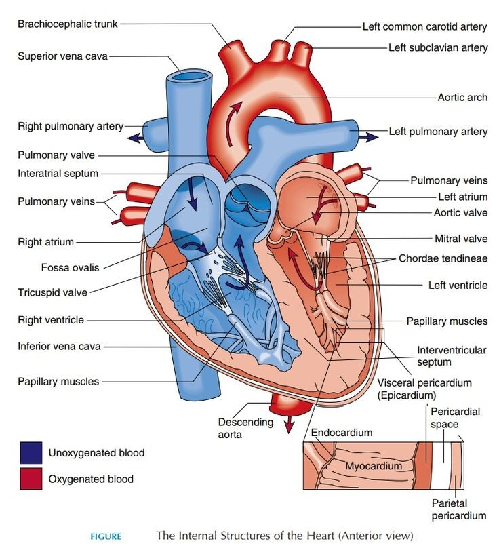
Figure 2- 1: The fundamental structure of the heart includes its chambers, principal blood vessels, and the conduction system, which comprises the sinoatrial node, atrioventricular node, and Purkinje fibers.

. Definition, Causes, and Epidemiology of Angina Pectoris
Angina pectoris refers to substernal chest pain, pressure, or discomfort that is typically exacerbated by exertion, anxiety, or other forms of mental or emotional stress. It generally lasts between 30 to 60 seconds and is relieved by rest or nitroglycerin. The discomfort may radiate to the arms, neck, lower jaw, epigastrium, or back and typically lasts between 5 to 15 minutes. Some patients describe the sensation as an ache or burning discomfort. In men, classic symptoms such as chest pain or pressure are more common, but atypical presentations, such as palpitations and dizziness, may also occur.
The primary cause of angina pectoris is an imbalance between the oxygen supply to the heart and its oxygen demand. This is commonly attributed to coronary artery disease (CAD), where atherosclerotic plaques narrow the coronary arteries, restricting oxygen and nutrient delivery to the myocardium. During exertion or emotional stress, the oxygen demand increases, leading to ischemia when the narrowed arteries cannot meet the heart's metabolic needs. Even plaques in earlier stages of atherosclerosis that do not severely limit blood flow may cause ischemia if they are vulnerable and rupture. Additionally, vasospasm of the coronary arteries can trigger angina episodes.
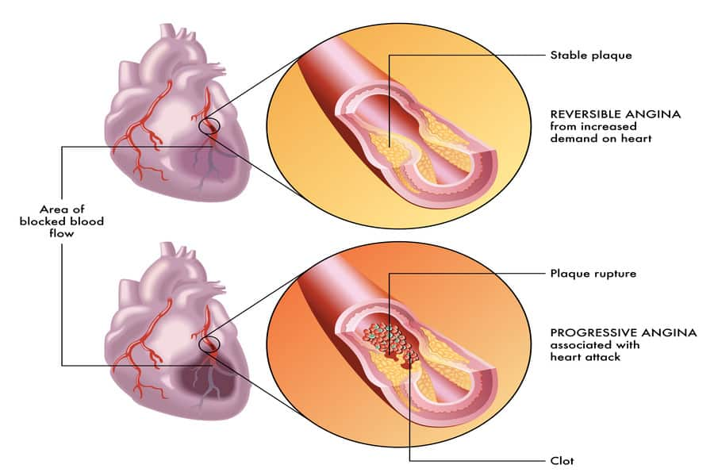
Figure 2- 2. angina pectoris, is a type of chest pain or discomfort stemming from an inadequate oxygen-rich blood supply to the heart muscle
Emerging evidence shows that microvascular disease, affecting small intramural coronary vessels, can also contribute to myocardial ischemia and angina symptoms. Structural heart conditions, including hypertrophic cardiomyopathy and valvular diseases such as aortic stenosis, are additional causes due to the persistent mismatch between oxygen demand and supply.

Symptoms, Causes, and Risk Factors of Angina Pectoris
Angina pectoris typically presents with a range of symptoms that vary in nature and intensity depending on the severity and underlying cause of the condition. The hallmark symptom is discomfort in the chest, which may be accompanied by other systemic manifestations. These symptoms can occur during physical exertion, emotional stress, or even at rest in more severe cases.
- Chest Discomfort:
  - A sensation of pressure, heaviness, squeezing, or burning in the chest.
  - The discomfort may be localized behind the sternum or spread to other regions of the chest.
- Radiation of Pain:
  - The discomfort often radiates to the shoulders, neck, lower jaw, back, or arms (particularly the left arm).
  - In some cases, it may be mistaken for gastric pain or musculoskeletal discomfort.
- Shortness of Breath:
  - Difficulty in breathing, especially during physical activity, may accompany angina due to inadequate oxygen supply to heart muscles.
- Fatigue:
  - A general sense of weakness or tiredness, even after minimal physical activity.
- Nausea and Vomiting:
  - Some patients, particularly women and older adults, may experience nausea or vomiting rather than the classic chest pain.
- Dizziness and Lightheadedness:
  - Reduced blood flow to the brain during an episode can cause dizziness or a feeling of imbalance.
- Excessive Sweating (Diaphoresis):
  - Profuse sweating may occur due to the activation of the sympathetic nervous system during an angina episode.
Atypical Symptoms in Women and the Elderly
Women and older adults often present with atypical symptoms such as fatigue, palpitations, or dyspnea without the classic chest discomfort. As a result, their diagnosis is often delayed, leading to poorer outcomes.
Angina results from an imbalance between oxygen supply and demand in the heart muscle. Several pathological mechanisms can reduce blood flow to the heart, leading to ischemic events.
- Coronary Artery Disease (CAD):
  - The most common cause of angina, characterized by the narrowing or blockage of coronary arteries due to the buildup of atherosclerotic plaques.
  - Plaques, composed of cholesterol and fatty deposits, limit the amount of oxygen-rich blood reaching the heart, especially during exertion.
- Coronary Artery Spasm:
  - A temporary tightening or constriction of the coronary arteries, reducing blood flow to the heart muscle.
  - Spasms may occur at rest or during sleep and can be triggered by stress, exposure to cold, or substance abuse.
- Coronary Microvascular Disease (MVD):
  - Involves dysfunction of the smallest coronary arteries without significant blockages.
  - This form of ischemia is more common in women and can present with atypical angina symptoms.
- Hypertrophic Cardiomyopathy:
  - Thickening of the heart muscle can impede proper blood flow and oxygen delivery, leading to angina.
- Aortic Valve Stenosis:
  - Narrowing of the aortic valve increases the workload on the heart, resulting in oxygen supply-demand mismatch.
- Anemia:
  - Low levels of hemoglobin reduce the blood's oxygen-carrying capacity, increasing the likelihood of ischemic events.

Risk Factors for Angina
Several modifiable and non-modifiable risk factors contribute to the development and progression of angina.

- Tobacco Use:
  - Smoking damages the endothelial lining of arteries, promotes inflammation, and accelerates the development of atherosclerosis.
- High Blood Pressure (Hypertension):
  - Chronic high blood pressure forces the heart to work harder, thickening the heart muscle and reducing coronary blood flow.
- Hyperlipidemia:
  - Elevated levels of low-density lipoprotein (LDL) cholesterol and triglycerides contribute to plaque formation and arterial narrowing.
- Diabetes Mellitus:
  - Chronic hyperglycemia damages blood vessels and promotes atherosclerosis, significantly increasing the risk of coronary artery disease.
- Age:
  - The risk of developing angina increases with age, particularly in men over 45 and women over 55 years old.

- Gender Differences:
  - While men develop coronary artery disease at a younger age, women tend to present with angina and ischemic events at older ages.
  - Hormonal changes post-menopause further elevate the risk in women.
- Physical Inactivity:
  - Sedentary lifestyles contribute to obesity, hypertension, and hyperlipidemia, all of which are risk factors for angina.
- Obesity:
  - Excess body weight increases the risk of metabolic syndrome, hypertension, and dyslipidemia, all of which are linked to coronary artery disease.
- Family History of Heart Disease:
  - A genetic predisposition to cardiovascular diseases increases the likelihood of developing angina.
- Chronic Stress and Emotional Factors:
- Stress can trigger coronary artery spasm and promote unhealthy behaviors like smoking and overeating.
- Dietary Factors:
- High intake of saturated fats, sugars, and processed foods contributes to obesity, hypertension, and atherosclerosis.

2.4. Different Types of Angina
Angina is classified into various types based on its underlying causes, clinical presentation, and response to treatment. Understanding these types is essential for accurate diagnosis and appropriate management.

12.4.1. Stable Angina (Angina Pectoris)
Stable angina is the most common and predictable form of angina. It typically occurs when the heart is working harder than usual, such as during physical exertion or emotional stress.
- Characteristics:
  - Predictable and follows a regular pattern.
  - Symptoms are often triggered by exertion or stress.
  - Episodes are short-lived, usually lasting between 5 to 15 minutes.
  - Relieved by rest or the administration of medications like nitroglycerin.
- Pathophysiology:
  - Caused by the narrowing of coronary arteries due to the buildup of atherosclerotic plaques.
  - The oxygen supply is insufficient to meet the increased demand of the heart during physical activity.
- Clinical Importance:
  - While manageable, stable angina is an indicator of underlying coronary artery disease and requires monitoring to prevent progression.

2.4.2. Unstable Angina
Unstable angina is a more dangerous and unpredictable condition that may occur even at rest. It represents a medical emergency and requires immediate intervention.
- Characteristics:
  - Unpredictable onset, often without a clear trigger.
  - Symptoms are more intense and prolonged than those of stable angina.
  - Episodes may not respond to rest or standard medications.

- Pathophysiology:
  - Often caused by the rupture of an atherosclerotic plaque, leading to partial or complete obstruction of the coronary artery.
  - Can be accompanied by blood clot formation and reduced blood flow to the heart.
- Clinical Importance:
  - Unstable angina is a warning sign of an impending myocardial infarction (heart attack) and demands immediate medical evaluation.
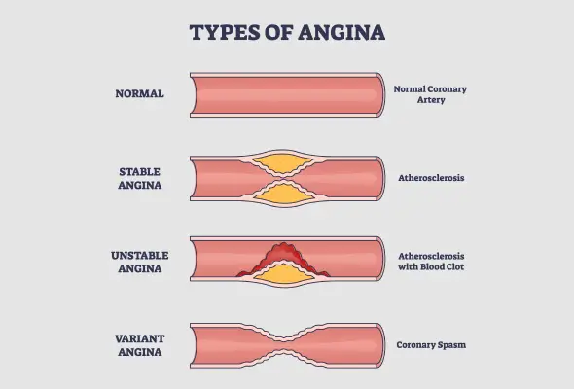
Figure 2- 3. Angina manifests in various forms, each with distinct characteristics and triggers.

2.4.3. Variant Angina (Prinzmetal's Angina)
Variant angina is a rare form caused by transient spasms in the coronary arteries. It can occur even in individuals without significant coronary artery disease.

- Characteristics:
  - Occurs at rest, often during nighttime or early morning hours.
  - Episodes may last longer than those of stable angina.
  - Can be relieved by medications that relax the coronary arteries, such as calcium channel blockers and nitrates.
- Pathophysiology:
  - Spasms temporarily reduce or completely block blood flow to the heart muscle.
  - Triggers may include exposure to cold, stress, smoking, or drug use.
- Clinical Importance:
  - Though less common, variant angina can lead to serious complications if not managed appropriately.

2.4.4. Microvascular Angina
Microvascular angina is caused by abnormalities in the smallest coronary arteries (microvasculature), which do not involve major blockages.
- Characteristics:
  - Symptoms can be more severe and longer-lasting compared to other types.
  - May occur during physical exertion or at rest.
  - Less predictable and often more resistant to traditional angina treatments.
- Pathophysiology:
  - Dysfunction in the endothelial or smooth muscle cells of the microvascular arteries, leading to impaired blood flow.
  - This type of angina is more common in women.
- Clinical Importance:
  - Diagnosing microvascular angina can be challenging due to the lack of significant blockages in coronary arteries.
  - Medications that improve blood vessel function, such as vasodilators and beta-blockers, may be effective..Biomarkers

2.4.5. Pathophysiology of Different Types of Angina:
1. Stable Angina:
It is caused by gradual and chronic narrowing of the coronary arteries due to the accumulation of atherosclerotic plaques. In this condition, blood flow is reduced during increased cardiac demand (such as physical exertion or stress), but symptoms typically resolve at rest.
2. Unstable Angina:
It usually results from the rupture of an atherosclerotic plaque and the formation of a blood clot, leading to partial or complete obstruction of the coronary artery. This type of angina can cause chest pain even at rest and may indicate a high risk of myocardial infarction.
3. Vasospastic (Prinzmetal’s) Angina:
This type of angina is caused by sudden and temporary spasm of the coronary artery, leading to a reduction in blood flow. It can occur at rest and is not directly related to atherosclerotic plaque formation.
Angina typically occurs due to reduced blood flow to the heart muscle, which is often caused by narrowing or blockage of the coronary arteries. Evaluating the levels of Proteinase-3 (PR3), angiotensin-converting enzyme (ACE), and visfatin as biological markers can aid in the early detection of different types of angina. Abnormal increases or decreases in these markers may be associated with inflammatory processes, vascular damage, and metabolic changes. Identifying and measuring these factors can improve the timely diagnosis and management of angina.

2.5.Biochemical factors

2.5.1.Troponin Relation with Angina Pectoris
Troponin is a critical biochemical marker for detecting myocardial damage, particularly in patients with unstable angina. The presence of myocardial injury, as indicated by elevated levels of cardiac troponin I (cTnI), has been shown to be a potent prognostic indicator. Studies have demonstrated that patients with elevated cTnI levels face a 2.5-fold increase in the relative risk of death or nonfatal myocardial infarction (MI) both at 30 days and at 1 year. Furthermore, cTnI provides independent prognostic value, complementing clinical assessments and electrocardiographic (ECG) findings in predicting adverse outcomes.
These findings align with previous research on cardiac troponin T (cTnT) in similar patient populations. For example, Hamm et al. reported that 39% of patients with Braunwald’s class III unstable angina had elevated cTnT levels, with 91% of cardiac events occurring in this group. Additional studies have confirmed a higher incidence of MI among patients with elevated cTnT at hospital admission, reinforcing the prognostic value of troponins. Moreover, research by Ravkilde et al. extended these observations, reporting a 24% two-year event rate in patients with unstable angina and elevated cTnT, compared with only 5% in those without elevations.
Cardiac troponin I is a highly specific marker for myocardial injury due to its absence in skeletal muscle, unlike cTnT, which has been found in some cases of skeletal muscle damage. Importantly, cTnI remains undetectable in healthy individuals, making even slight elevations significant. The sensitivity of cTnI in detecting myocardial necrosis is attributed to its approximately 13-fold higher concentration in the myocardium compared to CK-MB. Additionally, the narrower normal reference range of cTnI enhances its diagnostic precision.
The underlying mechanism linking troponin elevation to prognosis remains unclear. However, myocardial necrosis in unstable angina, potentially caused by active coronary thrombosis and subsequent embolization, may signify high-risk vascular territories. The detection of elevated cTnI levels suggests either minor myocardial necrosis or preceding cardiac injury before hospital presentation. This is supported by findings that two-thirds of patients in one study exhibited increased cTnI levels only after admission, despite normal CK-MB values.
Recent study is the first to establish the independent prognostic value of cTnI beyond ECG abnormalities in patients with severe unstable angina. While ECG changes, such as ST-segment deviations and T-wave inversions, have been associated with increased coagulant activity and adverse outcomes, their prognostic significance remains variable. Some studies have suggested that ST-segment changes predict poor outcomes, while others indicate that T-wave inversion carries increased risk, particularly in pain-free patients. In contrast, this data indicate that T-wave inversion was a weak predictor of cardiac events, though further investigation is needed.

2.5.2.Triglycerides (TG) Relation with Angina Pectoris
TG are one of the essential plasma lipids that play a crucial role in fat metabolism. Elevated TG levels in the blood are considered a risk factor for cardiovascular diseases, including angina pectoris. Angina pectoris typically results from reduced blood flow to the heart muscle due to narrowing or blockage of the coronary arteries. Increased TG levels contribute to the progression of atherosclerosis, the accumulation of fatty deposits in arterial walls, leading to arterial narrowing and decreased vascular flexibility.
Studies have shown that high TG levels may promote the production of remnant lipoproteins, which tend to accumulate in arterial walls and trigger inflammation. This process increases oxidative stress and endothelial inflammation, both of which play a significant role in the development of coronary artery disease. Furthermore, elevated TG levels can disrupt the balance between cardioprotective lipoproteins, such as HDL, and harmful lipoproteins, such as LDL, thereby increasing the risk of atherosclerotic plaque formation and angina pectoris.
Additionally, patients with metabolic syndrome and type 2 diabetes, who often exhibit high TG levels and insulin resistance, are at a significantly higher risk of developing angina pectoris and other cardiovascular complications. Clinical studies indicate that reducing TG levels through lifestyle modifications, such as adopting a healthy diet, increasing physical activity, and using lipid-lowering medications, can effectively lower the risk of angina pectoris and improve cardiovascular health. Therefore, controlling TG levels is a vital preventive and therapeutic measure in managing cardiovascular diseases.

2.5.3.White Blood Cells (WBCs) relation with Angina Pectoris
WBC count has been identified as a significant inflammatory marker associated with various cardiovascular conditions, including angina pectoris. Inflammatory responses play a crucial role in the progression of atherosclerosis and coronary artery disease (CAD), both of which contribute to angina. Increased WBC counts have been linked to endothelial dysfunction, microcirculatory disturbances, and plaque instability, all of which can trigger or exacerbate angina symptoms.
Several cohort studies have demonstrated the association between elevated WBC counts and cardiovascular events. For instance, Ates et al. reported that higher WBC counts correlated with the severity and extent of coronary atherosclerosis in patients suspected of having CAD. Additionally, increased WBC counts contribute to blood viscosity and microvascular dysfunction, potentially impairing myocardial oxygen supply, a key factor in angina pectoris. The rheological properties of leukocytes further influence capillary flow and endothelial interactions, which may exacerbate ischemic conditions.
Moreover, systemic inflammation, as indicated by higher WBC counts, has been associated with an increased risk of acute coronary syndromes, including unstable angina and myocardial infarction (AMI). The role of inflammation in plaque rupture and thrombosis highlights the potential of WBC count as a predictive marker for cardiovascular risk in patients with angina.

2.5.4.Low-density lipoprotein (LDL) Relation with Angina Pectoris
LDL cholesterol plays a crucial role in the development and progression of coronary artery disease (CAD), which is a major underlying cause of angina pectoris. The accumulation of LDL cholesterol in the arterial walls leads to the formation of atherosclerotic plaques, causing narrowing and hardening of the arteries. This process, known as atherosclerosis, reduces blood flow to the heart muscle, resulting in ischemia and anginal symptoms.
Numerous clinical trials have demonstrated that lowering LDL cholesterol can slow the progression of atherosclerosis, with some studies showing partial regression of coronary lesions. The most effective approach to lowering LDL levels includes the use of HMG-CoA reductase inhibitors (statins), which have been widely used in primary and secondary prevention of CAD. In patients with established CAD, intensive lipid-lowering therapy has been shown to reduce cardiovascular events, including angina pectoris, by improving coronary perfusion and stabilizing vulnerable plaques.
For patients with severe hypercholesterolemia, particularly those who do not achieve optimal LDL reduction with statins alone, LDL-apheresis has emerged as an advanced therapeutic option. This procedure selectively removes LDL cholesterol and other atherogenic lipoproteins from the plasma, leading to a significant reduction in LDL levels. Studies have indicated that regular LDL-apheresis sessions, in combination with statin therapy, can effectively reduce the progression of coronary atherosclerosis, improve endothelial function, and subsequently decrease the frequency and severity of angina attacks.
Despite the benefits of LDL reduction, the clinical impact of small angiographic changes remains a topic of ongoing investigation. Quantitative coronary angiography (QCA) has been used to assess the extent of coronary atherosclerosis and evaluate the effectiveness of LDL-lowering strategies. However, given that angiographic changes do not always translate into immediate clinical improvement, additional functional assessments, such as measuring coronary blood flow and myocardial perfusion, are necessary to determine the true impact of LDL reduction on angina pectoris.

2.5.5. Cholestrol Relation with Angina Pectoris
Cholesterol plays a crucial role in the development of coronary atherosclerosis, which is the primary cause of angina pectoris. Elevated cholesterol levels lead to the deposition of lipid-rich plaques within the coronary arteries, causing progressive narrowing and reducing oxygen supply to the heart muscle. This restriction in blood flow, known as ischemia, triggers angina symptoms, which manifest as chest pain or discomfort, particularly during physical exertion or emotional stress.
Over the years, clinical trials have consistently shown that cholesterol-lowering therapies play a vital role in preventing and managing CAD and angina pectoris. By lowering cholesterol, these therapies slow the progression of atherosclerosis and stabilize plaques, making them less likely to rupture and cause acute coronary events.
The assessment of cholesterol-related atherosclerosis has been significantly improved through advanced imaging techniques such as quantitative coronary angiography (QCA). Despite some limitations, QCA provides precise measurements of coronary stenosis and helps evaluate the impact of cholesterol-lowering therapies on arterial changes. However, since angiographic changes do not always correlate with symptom relief, additional functional measurements, such as coronary flow reserve and myocardial perfusion imaging, are necessary to better understand the clinical benefits of cholesterol reduction in angina pectoris management.
In conclusion, effective cholesterol management through lifestyle modifications, pharmacological treatments, and interventional therapies is essential for preventing and reducing the severity of angina pectoris. By achieving lower cholesterol levels, it is possible to improve coronary blood flow, reduce ischemic episodes, and enhance overall cardiovascular outcomes in patients with CAD.

2.6. Biomarkers
A biomarker, or biological marker, is a measurable molecule found in blood, other body fluids, or tissues that reflects normal or abnormal biological processes, diseases, or specific physiological conditions. Biomarkers are pivotal tools in modern medicine, bridging the gap between laboratory research and clinical practice. They play an essential role in early disease detection, monitoring treatment responses, and gaining insights into disease mechanisms, making them indispensable in the advancement of personalized medicine.
Biochemistry has significantly contributed to the application of biomarkers in clinical medicine, especially in disease diagnosis and management. Biomarkers are employed to detect metabolic disorders like diabetes or inherited metabolic conditions, monitor infectious diseases by identifying pathogen-specific molecules, and assess electrolyte imbalances through the measurement of ions such as sodium, potassium, and calcium. Enzyme activity serves as another critical area, where changes in enzymatic levels can help diagnose liver dysfunction, myocardial infarction, or pancreatic abnormalities. Similarly, hormonal assays measuring endocrine markers are vital for diagnosing disorders such as hypothyroidism or hyperthyroidism. In oncology, tumor markers—biomolecules elevated in certain cancers—provide valuable information for diagnosis, prognosis, and monitoring therapeutic outcomes.
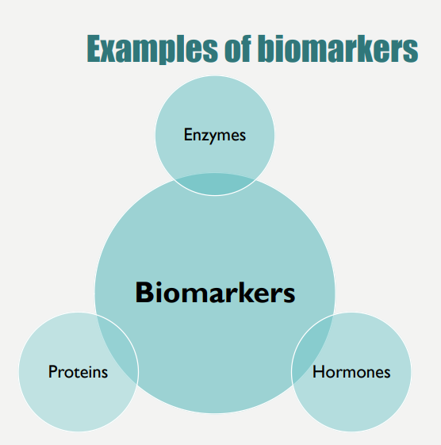
Figure 2- 4. Biomarkers Type

Biomarkers are broadly categorized based on their origin and function. Plasma-specific biomarkers are naturally present in the blood, where they perform their physiological roles and exhibit higher activity levels compared to tissues. In contrast, tissue-specific biomarkers are primarily located within cells, with only minimal amounts present in plasma due to normal cellular turnover. However, elevated concentrations of tissue-specific biomarkers in plasma often indicate cellular damage, aiding in the identification of conditions such as tissue injury or organ-specific diseases.
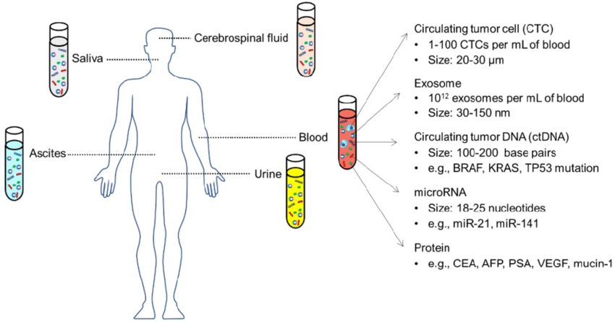
Figure 2- 5. Most common body fluids for the measurement of biomarkers are: Circulating biomarkers in different body fluids, including blood, urine, saliva, ascites, cerebrospinal fluid.

The measurement of biomarkers typically involves sampling various body fluids. Blood is the most commonly used medium due to its accessibility and comprehensive representation of systemic changes. Urine provides insight into kidney function and metabolic disorders, while saliva offers a non-invasive alternative for diagnosing infections or oral health issues. Cerebrospinal fluid (CSF) is crucial for detecting neurological conditions such as Alzheimer’s disease or meningitis, and ascitic fluid is used for evaluating infections or malignancies in patients with abdominal fluid accumulation.
To be clinically effective, biomarkers must meet specific criteria. An ideal biomarker should exhibit high sensitivity, enabling the detection of even small quantities, and high specificity, ensuring accurate identification of the target molecule without interference. Additionally, it should provide reliable and rapid results under various laboratory conditions to facilitate timely clinical decisions.
In conclusion, biomarkers are at the forefront of precision medicine, transforming the way diseases are diagnosed, monitored, and treated. Their ability to provide valuable insights into biological processes makes them indispensable for improving healthcare outcomes. As advancements in technology and research continue to expand the scope of biomarker discovery, their role in clinical practice will only grow, paving the way for more effective and individualized therapeutic approaches.

2.7. Role of adipose tissue in the pathogenesis of cardiovascular disease
Adipose tissue is now recognized as a dynamic organ actively involved in maintaining energy balance and supporting various physiological functions, including immune responses and inflammation. It secretes a variety of substances known as adipokines, including leptin, adiponectin, resistin, and visfatin. These molecules, released by fat cells or infiltrating macrophages, contribute to a chronic, low-grade inflammatory state that plays a significant role in the development of cardiovascular diseases.
The development of arrhythmias can be influenced by factors and conditions from early life. Studies have shown a strong association between obesity and an increased risk of arrhythmias, particularly in individuals from the general population and those undergoing certain types of heart surgeries. Obesity leads to an expansion of fat deposits that produce pro-inflammatory cytokines, reactive oxygen species, and an uncontrolled release of fatty acids, all of which contribute to cardiovascular issues. Excessive fat accumulation in the heart and surrounding tissues can disrupt heart function by promoting triglyceride buildup, impairing calcium signaling, and increasing inflammation and oxidative stress.
The infiltration of fat, often referred to as fatty metamorphosis, can damage heart muscle cells and lead to irregular heart rhythms. Obesity-induced inflammation is further fueled by the release of pro-inflammatory molecules from fat cells. Inflammatory markers have been associated with a higher likelihood of atrial fibrillation, and chronic inflammation can cause structural and electrical changes in the atria, increasing susceptibility to arrhythmias.
Adiponectin, an anti-inflammatory adipokine, is both an indicator and a potential regulator of cardiovascular health. It has protective properties against atherosclerosis, diabetes, and inflammation. Elevated adiponectin levels have been observed in persistent atrial fibrillation and are linked to structural changes in the heart's atria. These changes, driven by the activation of fibroblasts and the resulting fibrosis, contribute to disruptions in the heart's electrical conduction system.
Epicardial fat, the layer of fat surrounding the heart, significantly affects the electrical and contractile properties of the atria by releasing inflammatory molecules and interacting directly with heart muscle cells. This fat layer is particularly impactful in heart failure, disrupting the electrical activity of the left atrium and contributing to prolonged heart cell activation.
Fat accumulation within cells can interfere with the heart's electrical reset mechanism by reducing proteins involved in potassium channel formation, potentially leading to rapid and irregular heart rhythms. These disruptions are further influenced by the release of pro-inflammatory adipocytokines from epicardial fat, which extend the duration of electrical activation and increase the likelihood of irregular heartbeats.
Obesity also affects the heart’s electrical recovery process, as prolonged QT intervals are frequently observed in individuals with excessive fat, particularly in abdominal regions. Oxidative stress, often heightened in obese individuals, disrupts the function of ion channels in the heart, altering the electrical activity and promoting arrhythmias. Reactive oxygen species contribute to changes in ion channel behavior, weakening electrical signals and increasing the risk of irregular heart rhythms. Structural damage caused by oxidative stress has been confirmed in the hearts of patients with persistent arrhythmias, further highlighting its role in heart rhythm disorders.

2.7.1. Adipokines roles in heart function
The role of circulating adipokines in heart failure is critical, as these proteins, secreted by adipose tissue, significantly influence the development and progression of heart failure and other cardiovascular conditions. Fluctuations in the levels of adipokines such as apelin, adiponectin, chemerin, resistin, and retinol-binding protein 4 (RBP4) are closely linked to the risk and severity of heart failure. Investigating these variations provides valuable insights into the underlying mechanisms of heart failure and may pave the way for novel therapeutic strategies.
Obesity is strongly associated with chronic low-grade inflammation, which is believed to result from changes in cytokine expression by adipose tissue. Over the past two decades, research has demonstrated that adipose tissue produces immunomodulatory proteins, known as adipokines, which play a crucial role in regulating metabolic and cardiovascular functions.
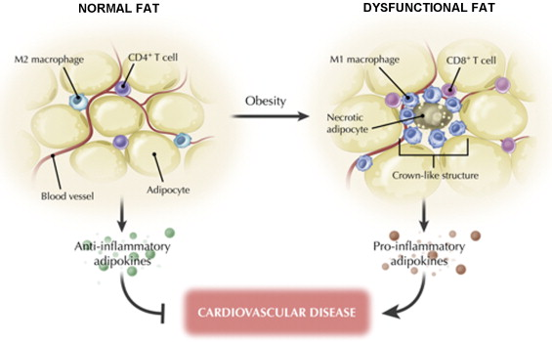
Figure 2- 6. Lean adipose tissue primarily secretes anti-inflammatory adipokines, such as adiponectin, while obesity is associated with elevated production of pro-inflammatory factors.

Although adipose tissue is predominantly located in visceral and subcutaneous regions, it is also distributed across various parts of the body. Deposits like epicardial, perivascular, and pulmonary adipose tissue are particularly important in cardiovascular disease. While different adipose depots vary in their production of adipokines, obesity generally enhances the secretion of pro-inflammatory adipokines, regardless of their location. Notably, studies in mice indicate that aging alone, even without obesity, can trigger the expression of pro-inflammatory adipokines like TNFα and IL-6 in visceral adipose tissue.
Most identified adipokines exhibit pro-inflammatory properties and are upregulated in obesity, contributing to metabolic and cardiovascular diseases. Key pro-inflammatory adipokines include TNFα, leptin, IL-6, resistin, RBP4, lipocalin 2, IL-18, and ANGPTL2. Despite this predominance of pro-inflammatory factors, adipose tissue also produces a smaller number of anti-inflammatory adipokines. Among these, adiponectin has been widely studied, and SFRP5 has recently gained attention for its anti-inflammatory potential.
Table 2- 1. Adipokines and cardiovascular function (47).
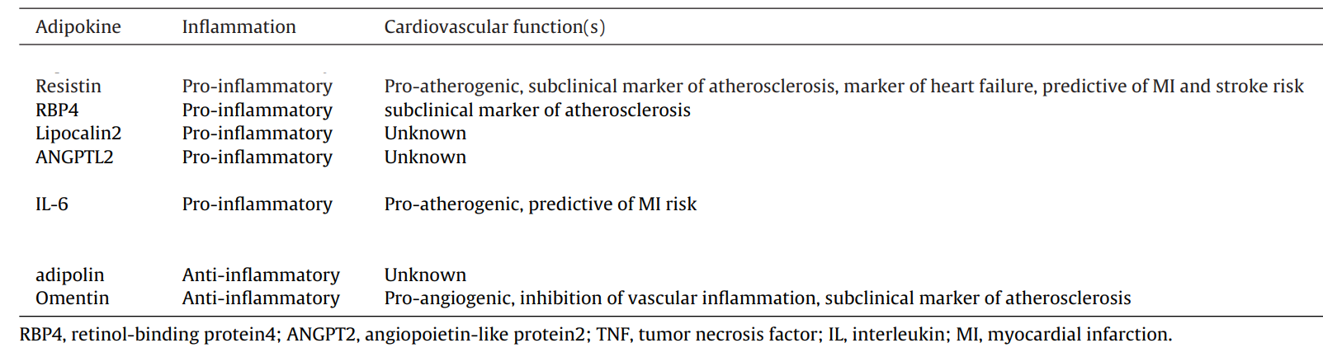
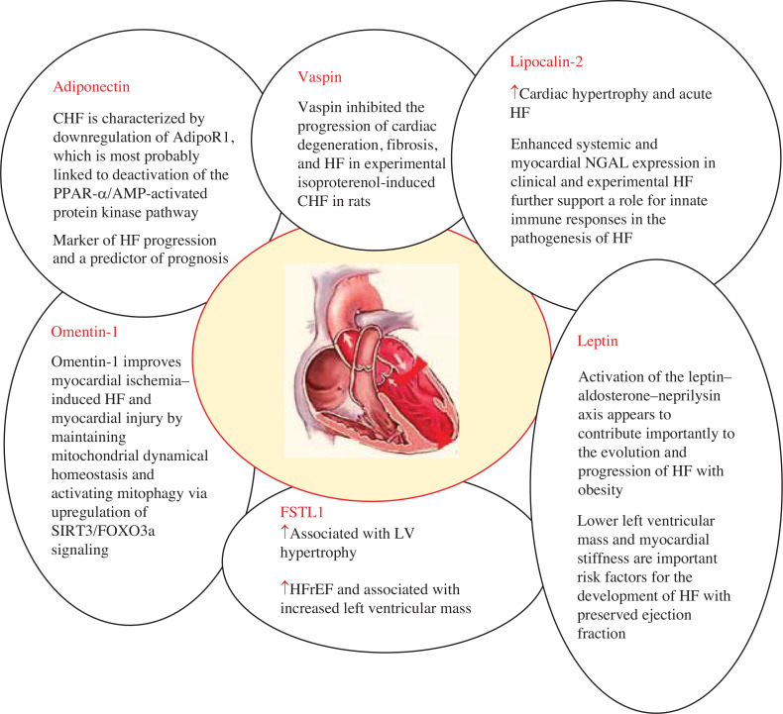
Figure 2- 7. Adipokines such as adiponectin, vaspin, lipocalin-2, omentin-1, leptin, and FSTL1 contribute to the development of heart failure.
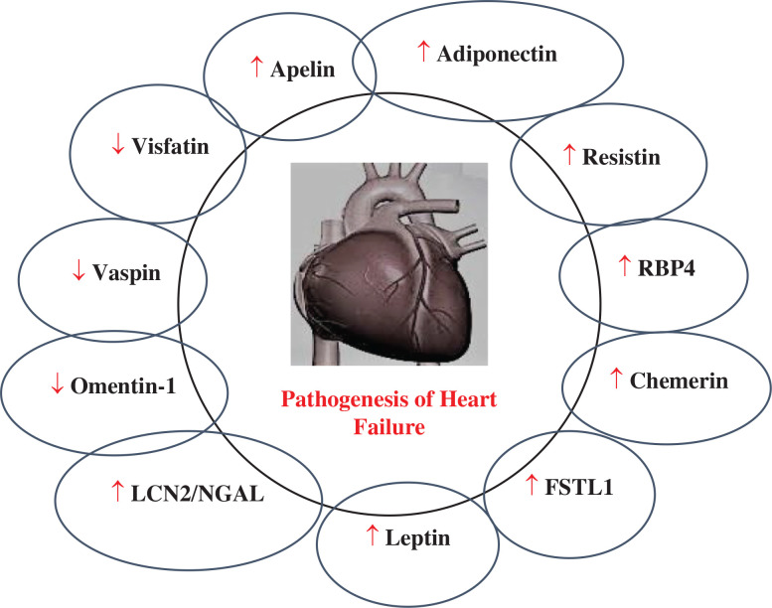
Figure 2- 8. The role of circulating levels of major adipokines in heart failure.

2.7.2. Visfatin
Visfatin, an adipokine discovered in 2004, has garnered significant attention due to its diverse biological functions and widespread expression across various tissues. Initially thought to be predominantly secreted by visceral adipose tissue, visfatin has since been identified in multiple cell types, including human leukocytes, skeletal muscles, hepatocytes, and other non-adipose tissues. This highly conserved protein has a molecular weight of approximately 52 kDa and is encoded by a gene comprising 491 amino acids. Due to its initial identification in pre–B-cell colony-enhancing factor studies, visfatin is also linked to the regulation of lymphocyte maturation and inflammatory pathways.
Beyond its classification as an adipokine, visfatin serves as nicotinamide phosphoribosyltransferase (NAMPT), an essential enzyme in the biosynthesis of nicotinamide adenine dinucleotide (NAD⁺), a crucial cofactor involved in cellular metabolism and energy production. This enzymatic role underscores visfatin’s importance in metabolic pathways and its broader implications in cellular function and survival. NAD⁺ biosynthesis is vital for maintaining mitochondrial function, redox balance, and regulating signaling pathways that influence gene expression, DNA repair, and apoptosis.
One of the most intriguing aspects of visfatin is its potential role in glucose metabolism. Studies in animal models have demonstrated insulin-mimetic effects of visfatin, with evidence suggesting that it can bind to and activate the insulin receptor, thereby lowering plasma glucose levels. However, human studies have yielded mixed findings. While some research indicates a positive association between visfatin levels and markers of adiposity, insulin resistance, and dyslipidemia, other studies have reported conflicting results. These discrepancies suggest that visfatin’s role in metabolic disorders, particularly obesity and insulin resistance, may be context-dependent and influenced by other metabolic and inflammatory factors.
Emerging evidence has linked visfatin levels to cardiovascular diseases, particularly heart failure. Research indicates that patients with systolic heart failure exhibit significantly lower serum visfatin concentrations compared to healthy individuals. These findings are particularly pronounced in individuals with more severe heart failure symptoms, independent of age, body mass index (BMI), or other metabolic factors. In addition, patients with heart failure often display altered metabolic and inflammatory profiles, including elevated high-sensitivity C-reactive protein (hs-CRP), increased glucose levels, higher insulin resistance scores, and reduced high-density lipoprotein (HDL) cholesterol levels.
Given visfatin’s multifaceted roles in metabolism, inflammation, and cardiovascular health, it presents as a potential biomarker for metabolic and cardiovascular disorders. Understanding the precise mechanisms underlying visfatin’s functions in humans requires further research to resolve the inconsistencies observed in clinical studies. The possibility of targeting visfatin pathways for therapeutic interventions, especially in metabolic syndrome, diabetes, and cardiovascular diseases, holds considerable promise. Nonetheless, more robust and comprehensive studies are necessary to elucidate its therapeutic potential and establish its role in clinical practice.

2.8. Role of Proteinase-3 (PR3)
PR3 is a multifunctional serine protease primarily found in the azurophilic granules and on the surface of polymorphonuclear leukocytes (PMNs). It plays a crucial role in immune and inflammatory responses and is recognized as the main target antigen for antineutrophilic cytoplasmic antibodies (ANCA). PR3 participates in local inflammatory responses by interacting with surface receptors and cleaving specific proteins. It is the primary target antigen for ANCAs, which are implicated in autoimmune diseases such as vasculitis. PR3 regulates and modulates cell activation processes by cleaving the protease-activated receptor-2 (PAR-2) and acts as a binding protein for the proinflammatory cytokine IL-32α, enhancing inflammatory signaling pathways. Studies suggest that ANCA-binding epitopes on PR3 are likely nonlinear and composed of complex sequences, highlighting the intricacies of its interactions with ANCA. In conclusion, PR3 is a key protein in immune and inflammatory pathways, interacting with various molecules, and it plays a significant role in autoimmune diseases, particularly those associated with ANCA.
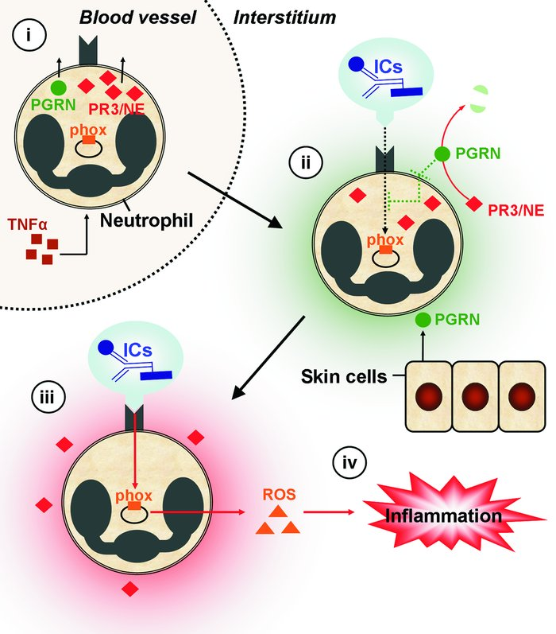
Figure 2- 9. Proposed function of PR3 and NE in IC-mediated inflammation.

2.8.1. PR3 and Its Role in Cardiovascular Disease
PR3 is a significant serine protease stored in the azurophilic granules of neutrophils and plays a critical role in inflammatory processes and immune responses. Its presence alongside other proteases such as elastase and cathepsin G highlights its importance in modulating extracellular matrix degradation and inflammatory signaling pathways. PR3 is not only released during strong stimuli to neutrophils but is also secreted in response to weaker stimuli, making it a versatile enzyme involved in vascular pathophysiology.
The role of PR3 in cardiovascular disease, particularly in coronary artery disease and acute myocardial infarction (AMI), is increasingly being recognized. Elevated neutrophil counts and activation have been associated with an increased risk of acute coronary syndromes, with PR3 contributing to plaque destabilization through extracellular matrix degradation and endothelial damage. PR3 may also be expressed on endothelial cells, where it exerts pro-inflammatory effects and induces apoptosis through caspase-like activity. Moreover, PR3 mediates the activation of cytokines such as tumor necrosis factor-alpha (TNFα), interleukin-1β (IL-1β), and interleukin-18 (IL-18), all of which are pivotal in vascular inflammation and myocardial injury.
Another crucial function of PR3 is its involvement in generating angiotensin I and II from angiotensinogen, which can exacerbate vasoconstriction and contribute to hypertension—a major risk factor for cardiovascular diseases. Despite its well-documented role in vasculitis, particularly in autoimmune conditions like Wegener's granulomatosis, the contribution of PR3 to morbidity and mortality in common cardiovascular conditions such as AMI remains less explored.
PR3 is typically inactivated by binding to SERPIN A1 (α1-antitrypsin), forming a stable PR3-SERPIN A1 complex. This interaction prevents unchecked proteolytic activity, thereby protecting vascular tissues from excessive damage. Since PR3 is more easily mobilized from secretory granules compared to other granule proteins such as myeloperoxidase (MPO), it may serve as a superior biomarker for neutrophil activation and inflammation in cardiovascular disease.
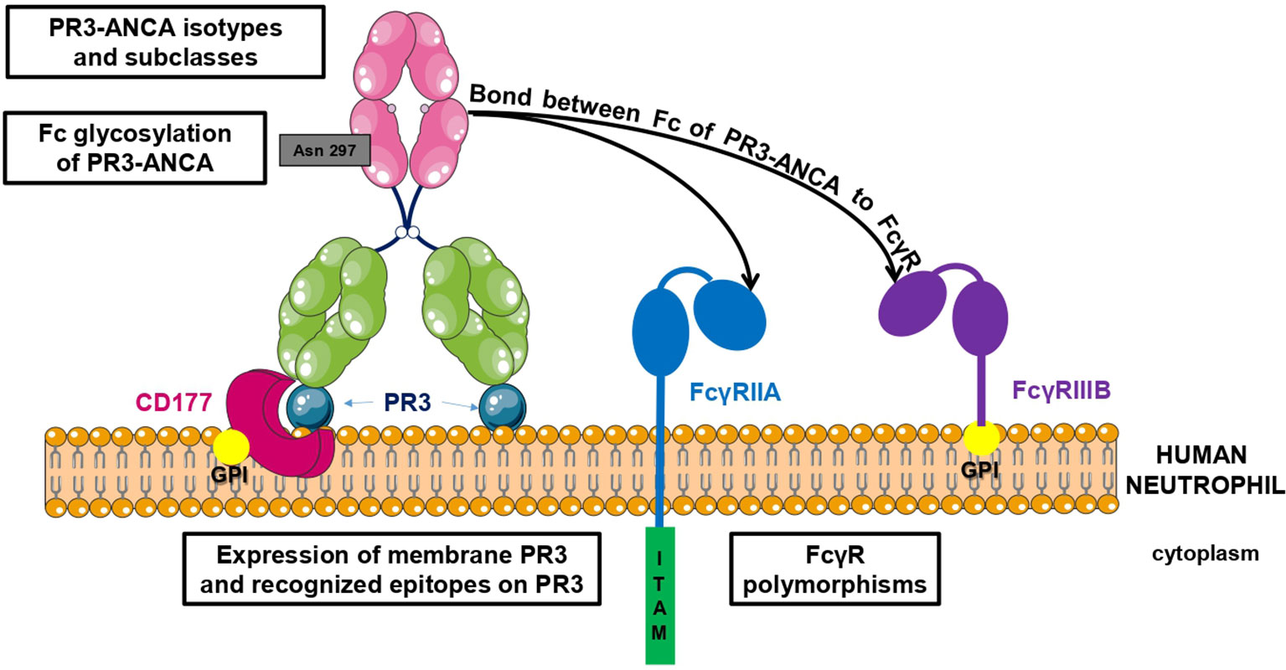
Figure 2- 10. Factors involved in PR3-ANCA pathogenicity. There are two types of interaction between PR3-ANCA and neutrophils: one includes a link between the PR3-ANCA Fab and mbPR3 exposed at the surface of neutrophils and the other involves a bond between the Fc of PR3-ANCA and FcγR. Pathogenicity of PR3-ANCA depends on many factors including the expression of membrane PR3 on neutrophils, the recognized epitopes, the presence or not of Fc gamma receptor polymorphisms, the subclasses and isotypes of PR3-ANCA, and finally the Fc glycosylation of PR3-ANCA.

2.9. Angiotensin-Converting Enzyme (ACE)
The ACE is a critical zinc-metallopeptidase enzyme that plays a pivotal role in the renin-angiotensin-aldosterone system (RAAS) by regulating blood pressure and fluid balance. ACE catalyzes the conversion of angiotensin I (Ang I), an inactive decapeptide, into angiotensin II (Ang II), a potent vasoconstrictor. Additionally, ACE degrades bradykinin, a vasodilatory peptide, thus influencing vascular tone and blood pressure regulation. Due to its dual role in generating Ang II and degrading bradykinin, ACE has become a significant target for pharmacological intervention in hypertension and cardiovascular diseases.
ACE was initially discovered in the 1950s when two pressor substances, Ang I and Ang II, were identified. Subsequent research in the 1960s characterized a bradykinin-degrading enzyme from the kidney, termed kininase II, which was later confirmed to be ACE. In 2000, a homolog of ACE, termed ACE2, was identified. Unlike ACE, ACE2 has unique enzymatic properties, converting Ang II into Ang(1–7), a vasodilatory peptide with cardioprotective functions. ACE2 has also gained prominence as the cellular receptor for the SARS coronavirus, linking it to respiratory viral pathogenesis.
Two isozymes of ACE exist in mammals: somatic ACE and testis ACE. Somatic ACE, expressed in various tissues, contains two catalytic domains (N- and C-domains) and a C-terminal transmembrane segment. Testis ACE, in contrast, possesses only a single catalytic domain. The enzymatic activity of ACE is dependent on its zinc-binding motif (HEMGH), where zinc ions are crucial for catalytic function. ACE2, a single-domain homolog of ACE, is a chimeric protein with a distinct C-terminal region resembling collectrin, which may assist in protein trafficking to cellular membranes.
The ACE gene is located on chromosome 17q23, while the ACE2 gene resides on Xp22. ACE is highly expressed in vascularized tissues, including the lungs, kidneys, and adrenal glands, with the lungs contributing significantly to plasma ACE activity. Testis ACE is expressed exclusively in postmeiotic male germ cells, where it plays a role in fertility. ACE2 is widely expressed in tissues such as the heart, lungs, kidneys, intestines, and testes.
ACE primarily regulates blood pressure by increasing Ang II levels and reducing bradykinin levels. Ang II mediates vasoconstriction, aldosterone secretion, and sodium retention, thereby elevating blood pressure. Beyond blood pressure regulation, ACE is involved in renal development, immune responses, and male fertility.
ACE2, on the other hand, counterbalances ACE activity by converting Ang II into Ang(1–7), which exerts vasodilatory, anti-inflammatory, and cardioprotective effects through the Mas receptor. The balance between ACE and ACE2 activities is critical for cardiovascular homeostasis, with ACE2 favoring protective mechanisms that mitigate hypertension and cardiac remodeling.
The discovery of ACE inhibitors marked a significant breakthrough in the treatment of hypertension and heart failure. Captopril, the first ACE inhibitor derived from snake venom peptides, was developed in the 1970s and remains a cornerstone therapy. Subsequent generations of ACE inhibitors, such as enalapril and ramipril, have reduced side effects like cough and angioedema.
Selective domain inhibitors targeting either the N- or C-domain of ACE have been developed to optimize therapeutic outcomes. For instance, RXPA380 selectively inhibits the C-domain, reducing Ang II synthesis while preserving bradykinin degradation to minimize adverse effects.
The identification of ACE2 has expanded therapeutic opportunities, particularly in the context of cardiovascular and pulmonary diseases. Overexpression of ACE2 in animal models has shown cardioprotective effects, suggesting its potential as a therapeutic target. Furthermore, ACE2's role as the receptor for SARS-CoV and SARS-CoV-2 underscores its significance in infectious disease research.
ACE and ACE2 are central components of the RAAS, with critical roles in cardiovascular and systemic homeostasis. While ACE promotes vasoconstriction and fluid retention, ACE2 provides counter-regulatory effects that protect against hypertension and cardiac dysfunction. The development of ACE inhibitors and the exploration of ACE2-based therapies highlight the translational impact of these enzymes in medicine. Ongoing research continues to refine our understanding of their functions, paving the way for novel therapeutic strategies targeting cardiovascular and infectious diseases.
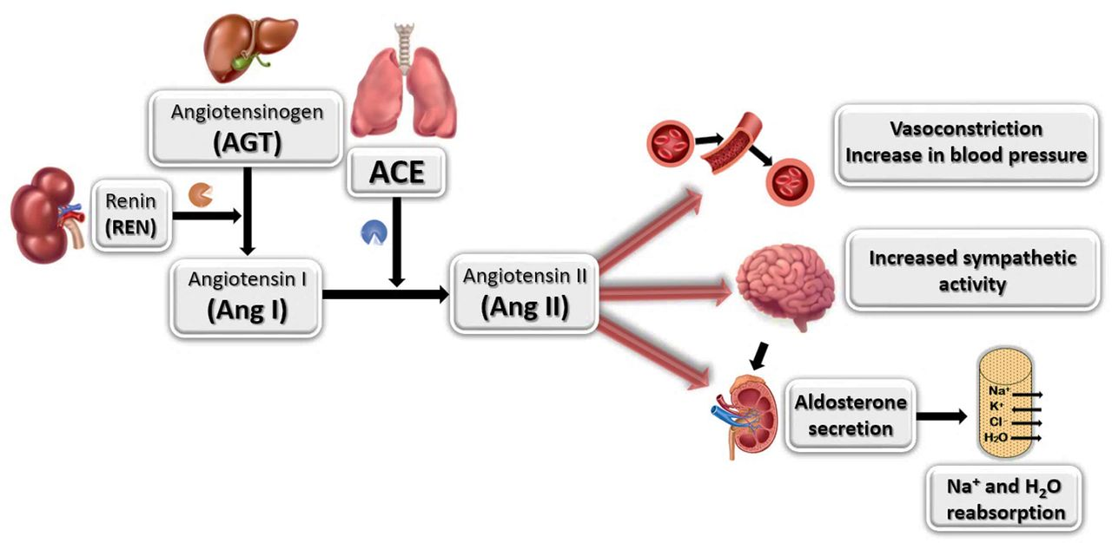
Figure 2- 11. Angiotensin-Converting Enzyme in the Human Heart

2.10. Research purpose
The aim of this study is to evaluate the levels of PR3, ACE, visfatin, and other biomarkers in male patients with stable and unstable angina in Kerbala Province. By comparing these levels with healthy controls, the study seeks to assess the diagnostic efficiency of these biomarkers and their potential role in early detection, ultimately contributing to improved management of cardiovascular diseases.

Chapter Three
Materials & Methods

3. Materials & Methods

3.1. Materials and general Equipment’s

Table 2- 1: Materials and general Equipment’s Laboratory
NO | Equipments or Instrument | Company | Country
1 | Incubator | Memmert | Germany
2 | Water bath | Memmert | Germany
3 | Centrifuge | kokasn | Japan
4 | Disposable syringes | Medjecte | Korea
5 | Mixer | boielab | China
6 | Eppedrof tubes | Fisher | USA
7 | Refrigerator | Beko | Turkish
8 | Cooton | Dunya cotton | Iraq
9 | Enzyme-linked immune sorbent assay (Eliza) system | Kayto | China
10 | Micropipette | Human pette | Germany
11 | Water distillator | Speromax | Germany
12 | Toledo self-zeroing  electronic digital scale | Mettler-Toledo, | USA
13 | Pasteur pipette | Nippon, sanof | France
14 | EDTA Tube | Arth alrafden | china
15 | Gel tube | Arth alrafden | china
16 | Filter paper | Difico | USA
17 | Micro titer wells plate | surgipath | China
18 | Autoclave | memmert | Germany
19 | Sample safe transport | Kish Termoos | Iran
20 | Mini Vidas | bioMerieux | France
21 | Automated hematology analyzer | Hemolyzer 3NG | Germany

3.2. Study population

3.2.1. Experimental design and participant
This study was conducted at Imam Hussein Medical City Emergency between and Cardiac Surgery Center October 2024 and January 2025. The study included 120 male individuals, comprising 90 patients diagnosed with angina and 30 healthy individuals serving as the control group. Figure 3.1 illustrates the classification of participants into distinct categories, namely patients and healthy individuals. Prior to participation, informed and written consent was obtained from all participants to ensure ethical compliance and voluntary involvement in the study.
The inclusion criteria for the angina patients required them to have a confirmed diagnosis of angina while not receiving any treatment at the time of enrollment. The control group consisted of individuals who were at least 30 years old and had no history of chronic illnesses, including heart disease, liver disease, diabetes (type 1 or type 2), kidney disease, neurodegenerative conditions, or regular use of iron supplements. These criteria were implemented to minimize confounding factors and ensure a reliable comparison between the two groups.

Figure 3- 1 The design of study
A case-control study was conducted on 120 individuals, including 90 patients with angina (45 with unstable angina and 45 with stable angina) and 30 healthy controls. Blood samples were collected from all participants to measure white blood cell count (W.B.C), glutathione peroxidase-1 (GPx-1), proteinase 3 (PR3), angiotensin-converting enzyme (ACE), visfatin, 4-hydroxynonenal (4-HNE), and troponin-1. The study design is illustrated in Figure (3-1).

3.3. Comprehensive Data Collection Through Structured Questionnaires
In line with established scientific research methodologies, data related to the health status of individuals—both healthy and affected—was systematically collected using a structured questionnaire. This approach ensured the accurate documentation of relevant health information while enhancing the accessibility and reliability of the study results.
The questionnaire was designed to gather comprehensive details about each participant, including personal and demographic information such as name, age, and medical history. Additionally, it covered key health-related aspects, including past and present medical conditions, lifestyle factors, medication usage, and any history of chronic or hereditary diseases. This structured data collection method facilitated a more in-depth analysis of potential health correlations and risk factors.
By incorporating these diverse elements, the questionnaire played a crucial role in standardizing data collection, minimizing biases, and ensuring consistency in the evaluation of participants' health profiles. Appendix.1 provides a visual representation of the categorization and structure of the collected information.

3.3.1. Sample Collection
As part of the data collection process, blood samples were obtained from both patients and healthy individuals (males), with a volume ranging from 3 to 5 milliliters. The collected blood samples were then subjected to centrifugation at 3000 rpm for 5 minutes to separate the serum. A total of 1500 µL of serum was extracted and transferred into test tubes.
. The prepared Eppendorf tubes were then stored at -20°C for future analyses.
- Inclusion criteria
- Male Patients with Angina (30-70) years
- Exclusion criteria
- Female Patients with Angina
- Male Patients with Angina less than 30 old years

3.4. Measurements of Biochemical parameters
Blood samples for analysis were collected from both patients and healthy individuals via the anterior vein using tubes.

3.4.1. Lipid profile levels
In this study, the lipid profile levels of patients were analyzed and compared with the control group. Plasma samples from patients were collected, and after centrifugation, the separated plasma was used for testing. Total cholesterol(TC), triglycerides (TG), and low-density lipoprotein (LDL) levels were measured using standard Bioelab kits. A specific volume of plasma samples, along with dedicated reagents, was added to the analyzer. After the enzymatic reaction process, optical absorbance was measured at designated wavelengths. The results were converted to quantitative values using a calibration curve and compared with reference values. Samples with cholesterol or triglyceride levels above the normal range were considered suspected cases of lipid metabolism disorders. The accuracy and precision of the tests were verified using quality control samples. After confirming data validity, the final results were recorded and reported.

Table 3- 2 Lipid Profile Test Kits
NO. | kit | company | origin
1 | Triglycrid | BIOELAB | China
2 | Cholestrol | BIOELAB | China
3 | LDL Cholestrol | BIOELAB | China

3.4.1.1. Test specific reagents
- Cholesterol Reagent
75 mmol/L PIPES buffer (pH 6.8), 10 mmol/L Mg²⁺, 0.2 mmol/L Sodium cholate, 0.15 mmol/L 4-Aminophenazone, 4.2 mmol/L Phenol, 0.5 U/mL Cholesterol esterase (EC 3.1.1.13; pseudomonas species; 25° C), 0.15 U/mL Cholesterol oxidase (EC 1.1.3.6; E. coli; 25° C), 0.25 U/mL Peroxidase (EC 1.11.1.7; horseradish; 25° C), 1% Fatty alcohol-polyglycol ether Buffer, unspecified stabilizers, unspecified preservative
- Triglyceride Reagents:
50 mmol/L PIPES buffer (pH 6.8), 40 mmol/L Mg²⁺, 0.20 mmol/L Sodium cholate, 1.4 mmol/L ATP, 0.13 mmol/L 4-Aminophenazone, 4.7 mmol/L 4-Chlorophenol, 1 μmol/L Potassium hexacyanoferrate (II), 0.65% Fatty alcohol polyglycolether, 5.0 U/mL lipoprotein lipase (EC 3.1.1.13; Pseudomonas species, 25 ºC), 0.19 U/mL glycerolkinase (EC 2.7.1.30; Bacillus stearotheromophilus; 25 ºC), 2.5 U/mL glycerophosphate oxidase (EC 1.1.3.21; E. coli; 25 ºC), 0.10 U/mL Peroxidase (EC 1.11.1.7; horseradish; 25 °C)
- HDL reagents, R1 and R2 contain the following components:

R1 Cyclodextrin/Buffer;
0.5 mmol/l α-cyclodextrin, 0.5 g/l dextran sulfate, 7.0 mg/ml magnesium sulfate (MgSO₄), 0.3 g/l EMSE, 10 mmol/l MOPS (3-morpholino-propane sulfonic acid) buffer (pH 7.0)
R2 Buffer/PEG-enzyme/4-Aminophenazone;
1 kU/l PEG cholesterol esterase (EC 3.1.1.13; Pseudomonas species; 25º C), 5.6 kU/l PEG cholesterol oxidase (EC 1.1.3.6; Pseudomonas species; 25ºC), 30 kU/l peroxidase (EC 1.11.1.7; horseradish; 25ºC), 0.5 g/l 4-aminophenazone, 10 mmol/l MOPS (3-morpholino-propane sulfonic acid) buffer (pH 7.0). The solutions are stable for 14 days at 2-12° C, or 7 days at room temperature (15-25° C).

3.4.2. CBC test
The CBC test was conducted using the CBC Kit (H3 Compact) manufactured by Anylitcon, Germany. It automatically measured various hematological parameters, including red blood cell (RBC) count, white blood cell (WBC) count, hemoglobin concentration, hematocrit levels, and platelet count. The procedure involved collecting blood samples from participants, which were then processed according to the kit's standardized protocol. The blood samples were carefully transferred into anticoagulant tubes to prevent clotting.
It automatically measured various hematological parameters, including RBC count, WBC count, hemoglobin concentration, hematocrit levels, and platelet count. Throughout the process, strict quality control measures were maintained to ensure the accuracy and reliability of the results. After analysis, the obtained data were systematically recorded for further evaluation and statistical analysis.

3.4.3. Troponin I test
In this test, the concentration of cardiac Troponin I in samples was measured using the High-Sensitive Troponin I kit from bioMérieux. The test was performed based on the Enzyme-Linked Fluorescent Assay (ELFA) method, which was executed automatically. So, Troponin I present in the sample reacted with monoclonal antibodies labeled with fluorescent markers. After washing, the fluorescence signal intensity was measured. After 20 minutes, the concentration of Troponin I in each sample was quantitatively displayed in (ng/L). The obtained data were analyzed and compared with reference values. Samples with Troponin I levels above the 99th percentile of healthy individuals (19 ng/L) were considered potential cases of cardiac injury or myocardial infarction (MI).

3.5. Enzyme-Linked Immunosorbent Assay (ELISA)
ELISA is widely recognized as one of the most commonly used labeled immunoassay techniques. It operates on the principle of an enzyme-linked antibody that specifically binds to an antigen immobilized on a solid surface, such as polystyrene plates with 96 or 384 wells. Upon introducing a substrate, a detectable color change or light signal is generated, reflecting the antigen concentration in the sample.
This method is highly valued for its efficiency, ease of use, and rapid detection of antigens or antibodies on a solid phase. Due to its exceptional sensitivity, ELISA is extensively applied in laboratory research, disease biomarker detection, and quality control processes across various industries. Elisa kits was used for determination other parameters.

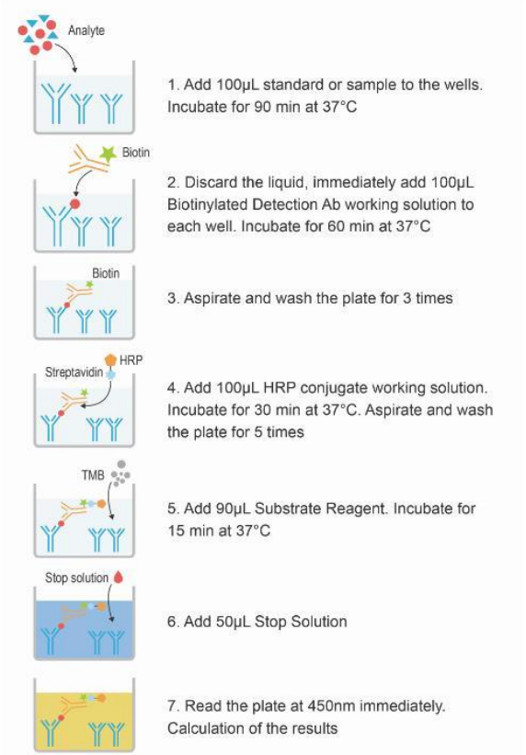
Figure 3- 2 The flowchart of ELISA (13).

Table 3- 3 List of ELISA Kits Used in the Study
No. | Kit | Co. | Source | Cat No.
1. | Gpx-1 kit | Sunlog | China | SL3451Hu
2. | 4- HNE kit | Sunlog | China | SL1895Hu
3. | ACE kit | Sunlog | China | SL0120Hu
4. | PR3 Kit | Sunlog | China | SL3230Hu
5. | Visfatin kit | Sunlog | China | MBS2506005

3.5.1. Preparation of Working Solutions:
- Wash Buffer: 30 mL of concentrated Wash Buffer was diluted with 720 mL of deionized or distilled water to prepare 750 mL of Wash Buffer. If crystals had formed in the concentrate, the solution was warmed in a 40°C water bath and gently mixed until the crystals were completely dissolved.
- Standard Working Solution: The standard was centrifuged at 10,000×g for 1 minute. Then, 1 mL of Reference Standard & Sample Diluent was added, and the solution was left to stand for 10 minutes. It was gently inverted several times to ensure complete dissolution, then thoroughly mixed with a pipette. This reconstitution produced a working solution of 20 μIU/mL. A serial dilution was performed to prepare solutions with concentrations of 10, 5, 2.5, 1.25, 0.63, 0.31, and 0 μIU/mL.
- Biotinylated Detection Antibody Working Solution: The required amount was calculated before the experiment, and slightly more than the calculated amount was prepared. The concentrated Biotinylated Detection Antibody was centrifuged at 800×g for 1 minute, then diluted at a ratio of 1:99 with Biotinylated Detection Antibody Diluent. The working solution was prepared just before use.
- HRP Conjugate Working Solution: The required amount of HRP Conjugate was calculated before the experiment, and slightly more than the calculated amount was prepared. The concentrated HRP Conjugate was centrifuged at 800×g for 1 minute, then diluted at a ratio of 1:99 with HRP Conjugate Diluent. The working solution was prepared just before use.
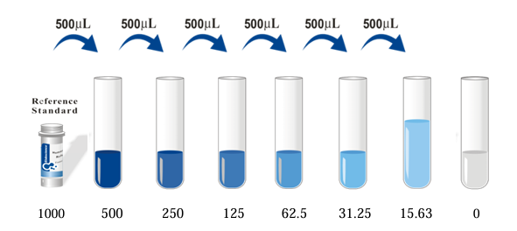
Figure 3- 3 Dilution method

3.5.2. Human 4-HNE elisa Assay Procedure
First, standard dilutions were prepared using a serial dilution method in small tubes:
- Standard No.1 (48 pmol/ml): 300 μl of the original standard was mixed with 150 μl of standard diluent.
- Standard No.2 (32 pmol/ml): 300 μl of Standard No.1 was combined with 150 μl of standard diluent.
- Standard No.3 (16 pmol/ml): 150 μl of Standard No.2 was mixed with 150 μl of standard diluent.
- Standard No.4 (8 pmol/ml): 150 μl of Standard No.3 was combined with 150 μl of standard diluent.
- Standard No.5 (4 pmol/ml): 150 μl of Standard No.4 was mixed with 150 μl of standard diluent.
A volume of 50 μl from each standard solution was pipetted into two wells of the MicroELISA plate, totaling ten wells for the standards. One well was left empty as a blank control.
In the sample wells, 40 μl of sample dilution buffer and 10 μl of the sample were added (dilution factor: 5). The samples were carefully pipetted to the bottom of the wells without touching the well walls, followed by gentle shaking to ensure proper mixing.
The plate was sealed with a closure plate membrane and incubated at 37°C for 30 minutes. The concentrated washing buffer was diluted with distilled water (30 times for a 96-well plate and 20 times for a 48-well plate). After incubation, the closure plate membrane was carefully removed, and the contents of the wells were aspirated. The wells were then refilled with the washing buffer and left for 30 seconds before aspirating the solution. This washing process was repeated five times. Next, 50 μl of HRP-conjugate reagent was added to each well, except for the blank control well. The plate was then incubated again at 37°C for 30 minutes. Following the incubation, the wells were washed again five times using the same washing procedure as before. To initiate the colorimetric reaction, 50 μl of Chromogen Solution A and 50 μl of Chromogen Solution B were added to each well. The plate was gently shaken to mix the solutions and then incubated at 37°C for 15 minutes in the dark to prevent light interference. To stop the reaction, 50 μl of stop solution was added to each well, resulting in a color change from blue to yellow. The optical density (O.D.) of each well was measured at 450 nm using a microplate reader. The O.D. value of the blank control well was set to zero. All measurements were completed within 15 minutes of adding the stop solution.

3.5.3. Human GPx-1 ELISA Assay Procedure
In this experiment, the dilution of standards and the MicroELISA assay for Human GPx-1 detection were performed. First, the standards were prepared using serial dilutions in small tubes. For Standard No.1 (48 pmol/ml), 300 μl of the original standard was mixed with 150 μl of standard diluent. For Standard No.2 (32 pmol/ml), 300 μl of Standard No.1 was mixed with 150 μl of standard diluent. Similarly, the serial dilutions continued: Standard No.3 (16 pmol/ml) was prepared by mixing 150 μl of Standard No.2 with 150 μl of standard diluent; Standard No.4 (8 pmol/ml) was prepared by mixing 150 μl of Standard No.3 with 150 μl of standard diluent; and Standard No.5 (4 pmol/ml) was prepared by mixing 150 μl of Standard No.4 with 150 μl of standard diluent.
Next, 50 μl of each standard was pipetted into two wells on the MicroELISA plate, resulting in a total of ten wells for the standards. One well was left empty as the blank control.
In the sample wells, 40 μl of sample dilution buffer and 10 μl of the sample were added (dilution factor: 5). The samples were carefully pipetted to the bottom of the wells without touching the walls, followed by gentle shaking for proper mixing.
The plate was then sealed with a closure plate membrane and incubated at 37°C for 30 minutes.
The concentrated washing buffer was diluted with distilled water (30 times for 96T and 20 times for 48T). After incubation, the closure plate membrane was carefully removed, and the solution in the wells was aspirated. The wells were refilled with the washing solution and left for 30 seconds before aspirating again. This washing process was repeated five times.
Then, 50 μl of HRP-conjugate reagent was added to each well, excluding the blank control well. The plate was incubated again at 37°C for 30 minutes, followed by another round of washing (five times) as previously described.
For the coloring reaction, 50 μl of Chromogen Solution A and 50 μl of Chromogen Solution B were added to each well. The plate was gently shaken to mix and incubated at 37°C for 15 minutes in the dark to prevent light interference.
To stop the reaction, 50 μl of stop solution was added to each well, causing the color to change from blue to yellow. The O.D. was measured at 450 nm using a microtiter plate reader. The O.D. value of the blank control well was set to zero. All measurements were taken within 15 minutes after adding the stop solution.

3.5.4. Human PR 3 ELISA Assay Procedure
First, one well was left empty as a blank control. Then, 40 μl of sample dilution buffer and 10 μl of the sample were added to each sample well (dilution factor: 5). The samples were carefully loaded onto the bottom without touching the well walls and mixed well with gentle shaking. Next, the plate was sealed with a closure plate membrane and incubated at 37°C for 30 minutes.
After incubation, the closure plate membrane was carefully peeled off. The solution in the wells 0wash solution was discarded. This washing procedure was repeated five times. Then, 50 μl of HRP-conjugate reagent was added to each well except the blank control well. The plate was incubated again at 37°C for 30 minutes, as described in Step 3. After incubation, the washing procedure was repeated five times, as described in Step 5.
For coloring, 50 μl of Chromogen Solution A and 50 μl of Chromogen Solution B were added to each well. The plate was gently shaken to mix and incubated at 37°C for 15 minutes, avoiding light during the coloring process.
For termination, 50 μl of stop solution was added to each well to stop the reaction. The color in the wells changed from blue to yellow. Finally, the absorbance (O.D.) was read at 450 nm using a microtiter plate reader. The O.D. value of the blank control well was set as zero. The assay was performed within 15 minutes after adding the stop solution.
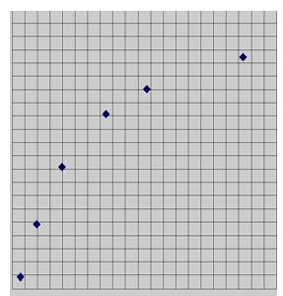
Figure 3- 4 Typical Standard Curve for PR3

3.5.5. Human ACE ELISA Assay Procedure
In this experiment, the MicroELISA method was used for sample measurement. First, one well was left empty as a blank control. Then, 40 μl of sample dilution buffer and 10 μl of the sample were added to each sample well (dilution factor: 1:5). The samples were carefully loaded at the bottom of the wells without touching the walls and mixed gently by shaking. For incubation, the plate was sealed with a closure membrane and incubated at 37°C for 30 minutes.
The washing buffer concentrate was diluted with distilled water (1:30 for a 96-well plate and 1:20 for a 48-well plate). After incubation, the closure membrane was carefully removed, and the solution in the wells was aspirated. The wells were then refilled with the washing solution, left for 30 seconds, and discarded. This washing procedure was repeated five times.
Next, 50 μl of HRP-conjugate reagent was added to each well except for the blank control well. The plate was incubated again at 37°C for 30 minutes, as described in the previous incubation step. The washing step was repeated five times as previously described. For the coloring reaction, 50 μl of Chromogen Solution A and 50 μl of Chromogen Solution B were added to each well. The plate was gently shaken to mix and incubated at 37°C for 15 minutes in the dark to avoid light exposure.
The reaction was terminated by adding 50 μl of stop solution to each well, resulting in a color change from blue to yellow. Finally, the OD was measured at 450 nm using a microplate reader. The OD value of the blank control well was set to zero. All measurements were taken within 15 minutes after adding the stop solution.

3.5.6. Measurement of Visfatin levels in Human serum
A competitive enzyme immunoassay technique was used in the ELISA kit. A polyclonal anti-Visfatin antibody and a Visfatin-HRP conjugate were utilized in the assay. The sample and buffer were incubated with the Visfatin-HRP conjugate in a pre-coated plate for one hour. After incubation, the wells were washed, and a substrate for the HRP enzyme was added, forming a blue complex. A stop solution was added to halt the reaction, turning the solution yellow. The color intensity, which was measured at 450 nm, was inversely proportional to the Visfatin concentration. A standard curve was used to determine the Visfatin concentration in the samples. The reagents for the measurement of Visfatin levels were shown in Figure (3-6).
The required number of coated wells was placed into the holder. 100 µL of the standard solutions was added to the assigned wells, ensuring that each standard bottle was gently shaken, and the solution was pipetted up and down three times before dispensing. For the blank control well, 100 µL of PBS (pH 7.0-7.2) was added. To each well, except for the blank control well, 50 µL of Conjugate was added, and thorough mixing was ensured. The plate was covered and incubated for one hour at 37°C. (Manual Washing) The incubation mixture was aspirated from the plate into a sink or waste container. Each well was filled with 1× wash solution, then aspirated again. This process was repeated for a total of five washes.
After washing, the plate was turned upside down and tapped onto an absorbent paper or towel until it appeared dry. When handling the plate, it was ensured that all strips were securely in the frame to prevent loss. To each well, including the blank control well, 50 µL of Substrate A followed by 50 µL of Substrate B was added. The plate was covered and incubated for 15-20 minutes at 37°C, avoiding exposure to sunlight. If the color development was weak, the incubation was extended up to 30 minutes. 50 µL of Stop Solution was added to every well, including the blank control well, and mixed well. The OD was measured at 450 nm with a microplate reader immediately after adding the Stop Solution.
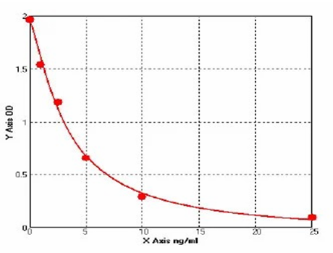
Figure 3- 5 Standard Curve of the Human Visfatin concentration.

The standard curve was utilized to ascertain sample quantities and the duplicate readings of each standard and sample were averaged. The mean value of the blank control was subtracted from all OD readings prior to analyzing results. The OD of the zero standard was not adjusted. A standard curve was created by plotting the standard concentrations on the X-axis against their corresponding average OD values on the Y-axis. Graphing paper or statistical software was used to establish a four-parameter logistic (4-PL) curve or a logit-log linear regression curve for the best fit.
Alternatively, the OD could be set up on the X-axis and the concentration on the Y-axis. To linearize the data, the logarithm of the concentrations could be plotted against the logarithm of the OD values, and regression analysis was used to find the most suitable line. The concentration of the samples was determined by matching their mean absorbance to the standard curve.

3.6. Statistical analysis
All experiments were repeated at least three times independently, and the data were reported as the mean ± standard deviation (SD). Statistical significance was determined using ANOVA, at a 5% significance level, with statistical significance set at p<0.05. Receiver Operating Characteristic (ROC) curve analysis was also performed to evaluate the diagnostic performance, with the area under the curve (AUC) being calculated to assess the accuracy of the test.

Chapter 4
Results

4. Results
This chapter presents the detailed findings of the study, which aimed to evaluate the levels of Proteinase-3 (PR3), angiotensin-converting enzyme (ACE), and visfatin as potential biomarkers for the early detection of different types of angina in males from Karbala Province. The results are organized based on the tables provided, and each table is discussed in detail to provide a comprehensive understanding of the findings.

Table(4- 1 ) shows the results gained for Troponin h.s levels in patients groups with control group , increase significantly (p≤0.01) in Troponin h.s levels of patients in comparison to control group at three different time points.
Table(4-1): The Comparison between (Troponin h.s) levels in patients and control at three different time points.
Parameters | Time (Troponin) | Control |  | Patient |  | P. value
Parameters | Time (Troponin) | Mean | Std. D. | Mean | Std. D. | P. value
Troponin h.s (ng/ml) | In 1 hour | 9.260 | ±2.081 | 99.199 | ±29.674 | 0.00002**
Troponin h.s (ng/ml) | After 6 hours | 9.260 | ±2.081 | 215.581 | ±63.665 | 0.00005**
Troponin h.s (ng/ml) | After 12 hours | 9.260 | ±2.081 | 281.632 | ±131.068 | 0.00006**
**The mean difference is significant at the 0.01 level.
Table(4- 2 ) shows the results acquired for serum visfatin ,ACE and PR3 levels in patients groups with control group, raise significantly (p≤0.01) in visfatin ,ACE and PR3of patients in comparison to control at three different time points.
Table(4-2): The Comparison between visfatin ,ACE and PR3levels in patients and control at three different time points.
Parameters | Time | Control |  | Patient |  | P. value
Parameters | Time | Mean | Std. D. | Mean | Std. D. | P. value
Visfatin(ng/ml) | In 1 hour | 0.729 | ±0.387 | 10.879 | ±2.936 | 0.00002**
Visfatin(ng/ml) | After 5 hours | 0.729 | ±0.387 | 14.733 | ±5.159 | 0.00001**
Visfatin(ng/ml) | After 10 hours | 0.729 | ±0.387 | 18.795 | ±8.934 | 0.00007**
ACE (ng/ml) | In 1 hour | 3.007 | ±0.676 | 9.582 | ±1.420 | 0.00006**
ACE (ng/ml) | After 5 hours | 3.007 | ±0.676 | 23.461 | ±4.386 | 0.00001**
ACE (ng/ml) | After 10 hours | 3.007 | ±0.676 | 28.379 | ±10.682 | 0.00009**
PR3 (pg/ml) | In 1 hour | 97.793 | ±6.344 | 421.758 | ±290.480 | 0.00045**
PR3 (pg/ml) | After 5 hours | 97.793 | ±6.344 | 545.461 | ±147.710 | 0.00002**
PR3 (pg/ml) | After 10 hours | 97.793 | ±6.344 | 408.227 | ±120.799 | 0.00006**
**The mean difference is significant at the 0.01 level.

Table(4-3) shows the results obtained for serum WBC,GPX-1 and 4-HNE levels in patients groups with control group , increase significantly (p≤0.01) in WBC,GPX-1 and 4-HNE levels of angina patients in comparison to control group .

Table(4- 3): The Comparison between WBC,GPX-1 and 4-HNE levels in patients and control.
Parameters | Control |  | Patient |  | P. value
Parameters | Mean | Std. D. | Mean | Std. D. | P. value
WBC/ml | 6082.337 | ±914.576 | 16078.038 | ±2395.067 | 0.00004**
GPX1 (pmol/ml) | 39.160 | ±6.018 | 13.272 | ±3.300 | 0.00001**
4-HNE (ng/ml) | 2.927 | ±0.635 | 11.944 | ±1.408 | 0.00001**
**The mean difference is significant at the 0.01 level.
Table (4-4) shows the results gained for serum TC,TG and LDL levels in patients groups with control group , rise significantly (p≤0.01) in TC,TG and LDL-c levels, of patients in comparison to control group .
Table (4-4): The Comparison between lipid profile levels in patients and their controls.
Parameters | Control |  | Patient |  | P. value
Parameters | Mean | Std. D. | Mean | Std. D. | P. value
TC (mg/dl) | 134.390 | ±14.482 | 412.969 | ±76.088 | 0.00002**
TG (mg/dl) | 117.823 | ±7.406 | 242.731 | ±28.431 | 0.00010**
LDL (mg/dl) | 99.573 | ±11.465 | 234.594 | ±49.631 | 0.00002**
**The mean difference is significant at the 0.01 level.
Table(4- 5 ) shows the results gained for Troponin h.s level in patients groups with control group, at three different time points(each 6 hour) , and according to the type of angina , rise significantly (p≤0.01) in Troponin h.s levels in ( 1 and 6 hour) and decrease significantly (p≤0.01) after (12 hour) in comparison at (1and 6 hour) of patients with stable angina in comparison to control group, and enlargement significantly (p≤0.01) in Troponin h.s level in patients with unstable angina compared with control group, at three different time points(each 6 hour).
Table(4- 5): The Comparison of groups at Each Time Point Separately for (Troponin h.s) levels according to the type of angina.
Parameter | Time | Control |  | Stable |  | Unstable |  | P. value
Parameter | Time | Mean | Std. D. | Mean | Std. D. | Mean | Std. D. | P. value
Troponin | in 1 hour | 9.260 | ±2.081 | 82.947 | ±20.211 | 115.451 | ±28.850 | 0.00002**
Troponin | After 6 hours | 9.260 | ±2.081 | 183.638 | ±53.627 | 247.524 | ±56.883 | 0.00004**
Troponin | After 12 hours | 9.260 | ±2.081 | 10.738 | ±1.756 | 552.526 | ±98.425 | 0.00002**
**The mean difference is significant at the 0.01 level.
Table(4- 6 ) shows the results acquired for serum visfatin ,ACE and PR3 levels in patients groups with control group, raise significantly (p≤0.01) in visfatin at three different time points(each 5 hour), in stable and unstable type of angina compared with control group , and show the elevation significantly (p≤0.01) in ACE and PR3levels in ( 1 and 5 hour) and decrease significantly (p≤0.01) in (10 hour) of patients with stable angina in comparison to control , increase significantly (p≤0.01) in ACE and PR3levels at( Each Time Point ) of patients with unstable angina in comparison to control group.
Table (4-6): The Comparison of visfatin ,ACE and PR3 levels at Each Time Point Separately according to the type of angina
Parameter | Time | Control |  | Stable |  | Unstable |  | P. value
Parameter | Time | Mean | Std. D. | Mean | Std. D. | Mean | Std. D. | P. value
Visfatin | In 1 hour | 0.729 | ±0.387 | 8.680 | ±1.548 | 13.078 | ±2.270 | 0.00005**
Visfatin | After 5 hours | 0.729 | ±0.387 | 9.946 | ±0.947 | 19.520 | ±2.462 | 0.00004**
Visfatin | After 10 hours | 0.729 | ±0.387 | 10.536 | ±1.044 | 27.053 | ±4.565 | 0.00002**
ACE | In 1 hour | 3.007 | ±0.676 | 8.682 | ±1.043 | 10.482 | ±1.154 | 0.00002**
ACE | After 5 hours | 3.007 | ±0.676 | 20.424 | ±2.367 | 26.498 | ±3.800 | 0.00009**
ACE | After 10 hours | 3.007 | ±0.676 | 2.429 | ±0.604 | 54.329 | ±7.889 | 0.00002**
PR3 | In 1 hour | 97.793 | ±6.344 | 374.811 | ±43.184 | 468.704 | 92.990 | 0.00128**
PR3 | After 5 hours | 97.793 | ±6.344 | 531.011 | ±46.393 | 559.911 | ±44.999 | 0.00005**
PR3 | After 10 hours | 97.793 | ±6.344 | 94.613 | ±4.134 | 721.840 | ±83.480 | 0.00003**
**The mean difference is significant at the 0.01 level

Table(4- 7 ) shows the results gained for WBC,GPX-1and 4-HNE level in patients groups with control group, according to the type of angina , rise significantly (p≤0.01) in WBC and 4-HNE levels and decrease significantly (p≤0.01) in GPX-1 of patients with stable and unstable angina in comparison to control group.
Table (4-7): The Comparison between WBC,GPX-1and 4-HNE levels according to the type of angina.
Parameters | Control |  | Stable |  | Unstable |  | P. value
Parameters | Mean | Std. D. | Mean | Std. D. | Mean | Std. D. | P. value
WBC | 6082.337 | ±914.576 | 15972.533 | ±2367.499 | 16183.542 | ±2444.432 | 0.00001**
GPX1 | 39.160 | ±6.018 | 14.598 | ±3.322 | 11.947 | ±2.720 | 0.00005**
4-NHE | 2.927 | ±0.635 | 11.229 | ±1.212 | 12.660 | ±1.221 | 0.00004**
**The mean difference is significant at the 0.01 level.
Table(4- 8 ) shows the results gained for TC,TG and LDL level s in patients groups with control group, according to the type of angina , escalation significantly (p≤0.01) in TC,TG and LDL levels of patients with stable and unstable angina in comparison to control group.
Table (4-8): The Comparison between lipid profile levels according to the type of angina.
Parameters | Control |  | Stable |  | Unstable |  | P. value
Parameters | Mean | Std. D. | Mean | Std. D. | Mean | Std. D. | P. value
TC | 134.390 | ±14.482 | 360.116 | ±59.997 | 465.822 | ±48.957 | 0.00008**
TG | 117.823 | ±7.406 | 244.773 | ±29.211 | 240.689 | ±27.807 | 0.00002**
LDL | 99.573 | ±11.465 | 216.662 | ±45.531 | 252.527 | ±47.452 | 0.00010**
**The mean difference is significant at the 0.01 level.
Table(4- 9 ) shows the results gained for Troponin h.s levels in patients groups with control group , increase significantly (p≤0.01) in Troponin h.s levels of patients in comparison to control group Over Time Within Each Group according to the type of angina.

Table (4-9): The Comparison of (Troponin h.s) Over Time Within Each Group according to the type of angina.
Parameter | Time | Control |  | Stable |  | Unstable |  | P. value
Parameter | Time | Mean | Std. D. | Mean | Std. D. | Mean | Std. D. | Time | Time × Group interaction
Troponin | In 1 hour | 9.260 | ±2.081 | 82.947 | ±20.211 | 115.451 | ±28.850 | 0.00008** | 0.00009**
Troponin | After 6 hours | 9.260 | ±2.081 | 183.638 | ±53.627 | 247.524 | ±56.883 | 0.00008** | 0.00009**
Troponin | After 12 hours | 9.260 | ±2.081 | 10.738 | ±1.756 | 552.526 | ±98.425 | 0.00008** | 0.00009**
**The mean difference is significant at the 0.01 level.

Table(4- 10) shows the results acquired for serum visfatin ,ACE and PR3 levels in patients groups with control group, significant difference (p≤0.01)in visfatin ,ACE and PR3 levels Over Time Within Each Group according to the type of angina.

Table( 4-10): The Comparison of visfatin ,ACE and PR3 levels Over Time Within Each Group according to the type of angina.
 | Parameter | Time |  | Control |  |  | Stable |  | Unstable |  | P. value
 | Parameter |  |  | Mean | Std. D. |  | Mean | Std. D. | Mean | Std. D. | Time | Time × Group interaction
 | Visfatin | In 1 hour |  | 0.729 |  | ±0.387 | 8.680 | ±1.548 | 13.078 | ±2.270 | 0.00003** | 0.00002**
 | Visfatin | After 5 hours |  | 0.729 |  | ±0.387 | 9.946 | ±0.947 | 19.520 | ±2.462 | 0.00003** | 0.00002**
 | Visfatin | After 10 hours |  | 0.729 |  | ±0.387 | 10.536 | ±1.044 | 27.053 | ±4.565 | 0.00003** | 0.00002**
 | ACE |  | In 1 hour | 3.007 | ±0.676 |  | 8.682 | ±1.043 | 10.482 | ±1.154 | 0.00003** | 0.00004**
 |  |  | After 5 hours | 3.007 | ±0.676 |  | 20.424 | ±2.367 | 26.498 | ±3.800 | 0.00003** | 0.00004**
 |  |  | After 10 hours | 3.007 | ±0.676 |  | 2.429 | ±0.604 | 54.329 | ±7.889 | 0.00003** | 0.00004**
 | PR3 |  | In 1 hour | 97.793 | ±6.344 |  | 374.811 | ±43.184 | 468.704 | ±92.990 | 0.03120** | 0.00002**
 |  |  | After 5 hours | 97.793 | ±6.344 |  | 531.011 | ±46.393 | 559.911 | ±44.999 | 0.03120** | 0.00002**
 |  |  | After 10 hours | 97.793 | ±6.344 |  | 94.613 | ±4.134 | 721.840 | ±83.480 | 0.03120** | 0.00002**
**The mean difference is significant at the 0.01 level.
Table(4- 11 ) displays the results acquired for serum visfatin ,ACE and PR3 levels in patients groups with control group, raise significantly (p≤0.01) in visfatin at three different time points(each 5 hour), in stable and unstable type of angina compared with control group , and show the elevation significantly (p≤0.01) in ACE and PR3levels in ( 1 and 5 hour) and decrease significantly (p≤0.01) in (10 hour) of patients with stable angina in comparison to control , increase significantly (p≤0.01) in ACE and PR3levels at( Each Time Point ) of patients with unstable angina in comparison to control group, according to the age grou
Table (4-11): The Comparison of groups at Each Time Point Separately according to the age groups.
Parameters | Time | Age Group | Control |  | Stable |  | Unstable |  | P. value
Parameters | Time | Age Group | Mean | Std. D. | Mean | Std. D. | Mean | Std. D. | P. value
Visfatin | In  1 hour | Less than 50 | 0.782 | 0.431 | 7.102 | 1.886 | 15.075 | 0.826 | 0.00006**
Visfatin | In  1 hour | Greater & equal than 50 | 0.659 | 0.325 | 8.878 | 1.407 | 12.883 | 2.275 | 0.00005**
Visfatin | After 5 hours | Less than 50 | 0.782 | 0.431 | 9.800 | 1.185 | 22.175 | 2.081 | 0.00003**
Visfatin | After 5 hours | Greater & equal than 50 | 0.659 | 0.325 | 9.964 | 0.930 | 19.261 | 2.360 | 0.00006**
Visfatin | After 10 hours | Less than 50 | 0.782 | 0.431 | 10.802 | 1.156 | 27.650 | 4.502 | 0.00001**
Visfatin | After 10 hours | Greater & equal than 50 | 0.659 | 0.325 | 10.503 | 1.040 | 26.995 | 4.622 | 0.00001**
ACE | In  1 hour | Less than 50 | 2.818 | 0.792 | 8.540 | 1.016 | 11.475 | 1.087 | 0.00003**
ACE | In  1 hour | Greater & equal than 50 | 3.254 | 0.389 | 8.700 | 1.058 | 10.385 | 1.126 | 0.00008**
ACE | After 5 hours | Less than 50 | 2.818 | 0.792 | 20.000 | 2.042 | 26.650 | 5.725 | 0.00007**
ACE | After 5 hours | Greater & equal than 50 | 3.254 | 0.389 | 20.478 | 2.423 | 26.483 | 3.663 | 0.00001**
ACE | After 10 hours | Less than 50 | 2.818 | 0.792 | 2.340 | 0.744 | 51.175 | 10.225 | 0.00007**
ACE | After 10 hours | Greater & equal than 50 | 3.254 | 0.389 | 2.440 | 0.594 | 54.637 | 7.716 | 0.00007**
PR3 | In  1 hour | Less than 50 | 96.865 | 7.942 | 399.880 | 65.162 | 352.425 | 40.045 | 0.00004**
PR3 | In  1 hour | Greater & equal than 50 | 99.008 | 3.218 | 371.678 | 39.721 | 480.049 | 725.710 | 0.04984**
PR3 | After 5 hours | Less than 50 | 96.865 | 7.942 | 530.960 | 76.700 | 580.075 | 53.661 | 0.00007**
PR3 | After 5 hours | Greater & equal than 50 | 99.008 | 3.218 | 531.018 | 42.718 | 557.944 | 44.349 | 0.00002**
PR3 | After 10 hours | Less than 50 | 96.865 | 7.942 | 93.900 | 3.953 | 740.450 | 69.595 | 0.00003**
PR3 | After 10 hours | Greater & equal than 50 | 99.008 | 3.218 | 94.703 | 4.196 | 720.024 | 85.233 | 0.00004**
**The mean difference is significant at the 0.01 level.

Table(4- 12 ) shows the results increased for Troponin h.s level in patients groups with control group, at three different time points(each 6 hour) , and according to the type of angina , rise significantly (p≤0.01) in Troponin h.s levels in ( 1 and 6 hour) and decrease significantly (p≤0.01) after (12 hour) in comparison at (1and 6 hour) of patients with stable angina in comparison to control group, and enlargement significantly (p≤0.01) in Troponin h.s level in patients with unstable angina compared with control group, at three different time points (each 6 hour), according to the age groups.
Table(4-12): The Comparison of groups at Each Time Point Separately according to the age groups.
Parameters | Time | Age Group | Control |  | Stable |  | Unstable |  | P. value
Parameters | Time | Age Group | Mean | Std. D. | Mean | Std. D. | Mean | Std. D. | P. value
Troponin | In  1 hour | Less than 50 | 8.900 | 2.123 | 75.180 | 25.840 | 113.025 | 10.361 | 0.00002**
Troponin | In  1 hour | Greater & equal than 50 | 9.731 | 2.009 | 83.918 | 19.587 | 115.688 | 30.114 | 0.00001**
Troponin | After 6 hours | Less than 50 | 8.900 | 2.123 | 163.040 | 74.125 | 280.675 | 33.290 | 0.00004**
Troponin | After 6 hours | Greater & equal than 50 | 9.731 | 2.009 | 186.213 | 51.184 | 244.290 | 57.926 | 0.00003**
Troponin | After 12 hours | Less than 50 | 8.900 | 2.123 | 10.200 | 1.010 | 586.725 | 89.523 | 0.00005**
Troponin | After 12 hours | Greater & equal than 50 | 9.731 | 2.009 | 10.805 | 1.825 | 549.190 | 99.634 | 0.00001**
**The mean difference is significant at the 0.01 level.
Table(4- 13) shows the results added for TC,TG and LDL level s in patients groups with control group, according to the type of angina , escalation significantly (p≤0.01) in TC,TG and LDL levels of patients with stable and unstable angina in comparison to control group, according to the age groups.

Table(4-13): The Comparison of lipid profile at Each Time Point Separately according to the age groups.
Parameters | Age Group | Control |  | Stable |  | Unstable |  | P. value
Parameters | Age Group | Mean | Std. D. | Mean | Std. D. | Mean | Std. D. | P. value
TC | Less than 50 | 137.529 | 12.329 | 356.400 | 76.153 | 435.750 | 70.073 | 0.00001**
TC | Greater & equal than 50 | 130.285 | 16.490 | 360.580 | 58.859 | 468.756 | 46.572 | 0.00002**
TG | Less than 50 | 116.629 | 6.622 | 248.000 | 21.366 | 270.500 | 21.237 | 0.00006**
TG | Greater & equal than 50 | 119.385 | 8.332 | 244.370 | 30.239 | 237.780 | 26.817 | 0.00009**
LDL | Less than 50 | 101.241 | 11.827 | 218.960 | 23.348 | 277.675 | 59.266 | 0.00005**
LDL | Greater & equal than 50 | 97.392 | 11.049 | 216.375 | 47.772 | 250.073 | 46.304 | 0.00003**
**The mean difference is significant at the 0.01 level.
Table(4- 14 ) shows the results increased for WBC,GPX-1and 4-HNE level in patients groups with control group, according to the type of angina , rise significantly (p≤0.01) in WBC and 4-HNE levels and decrease significantly (p≤0.01) in GPX-1 of patients with stable and unstable angina in comparison to control group, according to the age groups.

Table(4-14) : The Comparison of groups at Each Time Point Separately according to the age groups.
Parameters | Age Group | Control |  | Stable |  | Unstable |  | P. value
Parameters | Age Group | Mean | Std. D. | Mean | Std. D. | Mean | Std. D. | P. value
WBC | Less than 50 | 6216.512 | 880.279 | 16464.740 | 3041.032 | 17025.250 | 2410.647 | 0.00001**
WBC | Greater & equal than 50 | 5906.877 | 964.040 | 15911.008 | 2310.888 | 16101.424 | 2461.538 | 0.00002**
GPX-1 | Less than 50 | 38.371 | 5.811 | 15.840 | 2.745 | 11.650 | 1.816 | 0.00002**
GPX-1 | Greater & equal than 50 | 40.192 | 6.361 | 14.443 | 3.384 | 11.976 | 2.808 | 0.00006**
4-HNE | Less than 50 | 2.729 | 0.625 | 12.420 | 0.589 | 12.525 | 1.482 | 0.00004**
4-HNE | Greater & equal than 50 | 3.185 | 0.570 | 11.080 | 1.191 | 12.673 | 1.214 | 0.00003**
**The mean difference is significant at the 0.01 level.
Figure (4- 1 ) shows the results acquired for serum Troponin levels in patients groups with control group, raise significantly (p≤0.01) in Troponin at three different time points (each 6 hour), in patients compared with control group
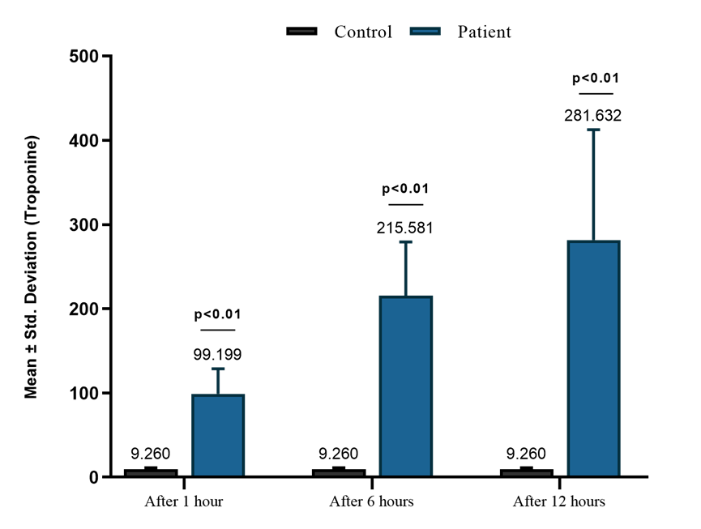
Figure(4-1) : The Comparison between Troponin level in patients and their controls at three different time points.

Figure (4- 2 ) shows the results acquired for serum visfatin levels in patients groups with control group, raise significantly (p≤0.01) in visfatin of patients in comparison to control at three different time points.
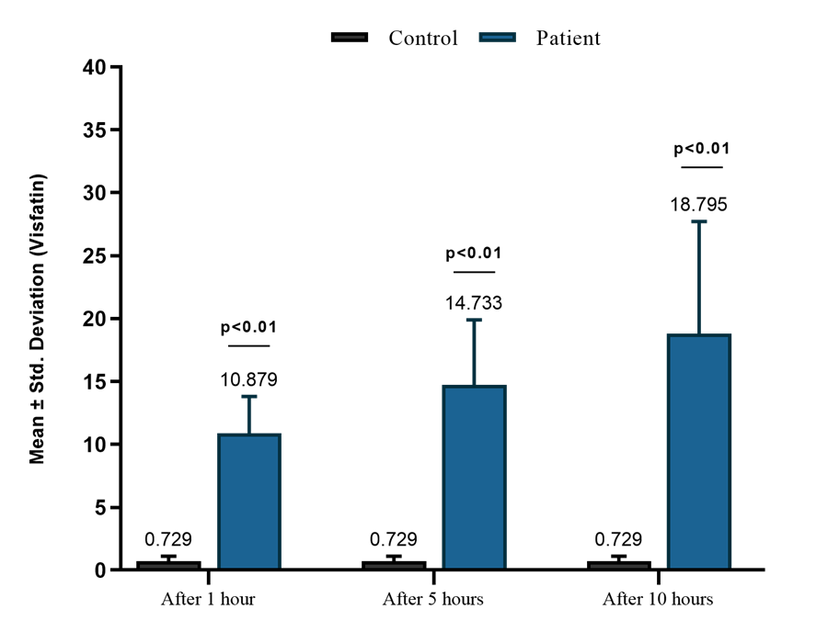
Figure(4-2): The Comparison between Visfatin level in patients and their controls at three different time points
Figure (4- 3) displays the results acquired for serum ACE levels in patients groups with control group, raise significantly (p≤0.01) in ACE of patients in comparison to control at three different time points.
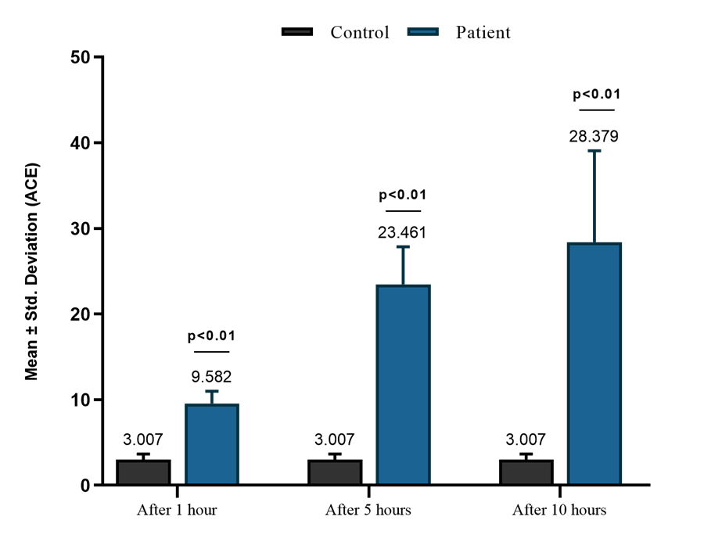
Figure(4-3) : The Comparison between ACE level in patients and their controls at three different time points.

Figure (4- 4) shows the results acquired for serum PR3 levels in patients groups with control group, raise significantly (p≤0.01) in PR3of patients in comparison to control group at three different time points.
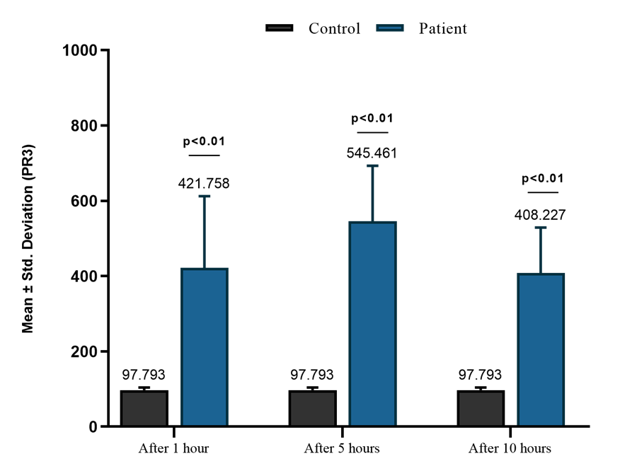
Figure (4-4): The Comparison between PR3 level in patients and their controls at three different time points.

Figure (4-5) shows the results obtained for serum WBC levels in patients groups with control group , increase significantly (p≤0.01) in WBC levels of angina patients in comparison to control group .
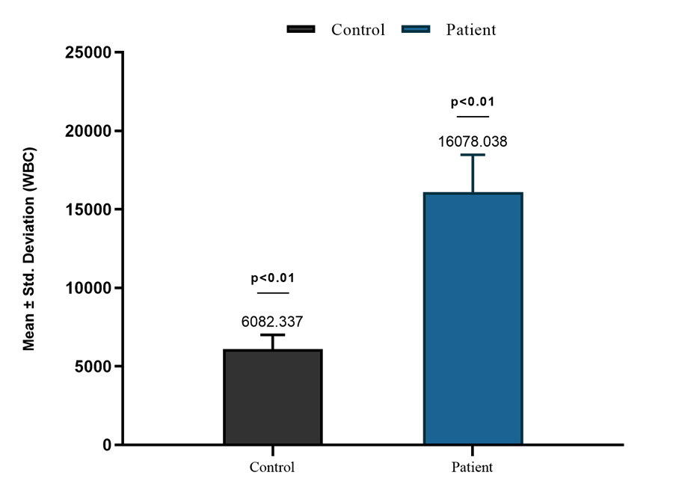
Figure( 4-5): The Comparison between WBC in patients and control.
Figure (4-6) shows the results acquired for serum GPX-1 and 4-HNE levels in patients groups with control group , increase significantly (p≤0.01) in GPX-1 and 4-HNE levels of angina patients in comparison to control group .
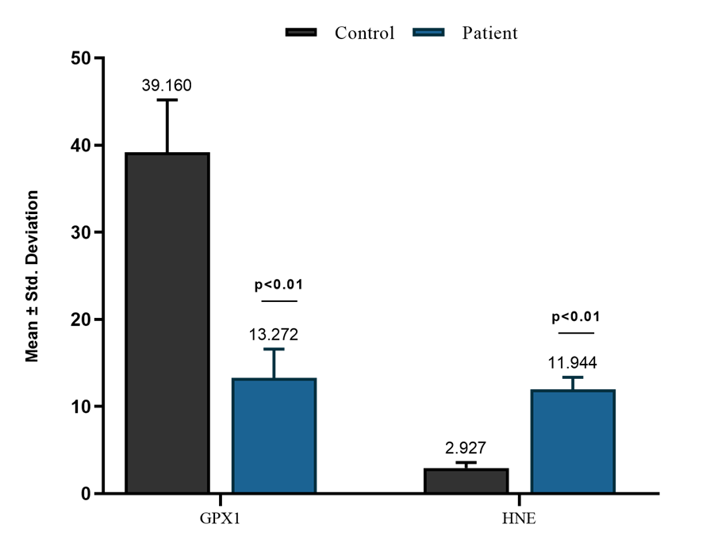
Figure (4-6): The Comparison between GPX-1 and 4- HNE in patients and their control.
Figure (4- 7 ) shows the results gained for TC,TG and LDL level s in patients groups with control group, according to the type of angina , increase significantly (p≤0.01) in TC,TG and LDL levels of patients with angina in comparison to control group.
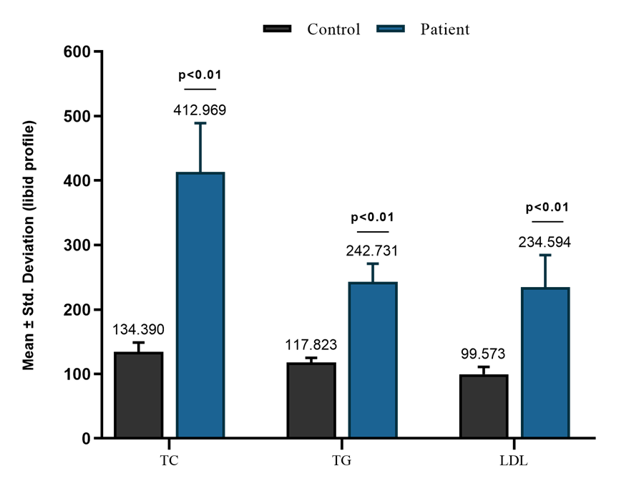
Figure( 4-7): The Comparison between lipid profile in patients and control .

Figure (4- 8 ) shows the results gained for Troponin h.s level in patients groups with control group, at three different time points(each 6 hour) , and according to the type of angina , rise significantly (p≤0.01) in Troponin h.s levels in ( 1 and 6 hour) and decrease significantly (p≤0.01) after (12 hour) in comparison at (1and 6 hour) of patients with stable angina in comparison to control group, and enlargement significantly (p≤0.01) in Troponin h.s level in patients with unstable angina compared with control group, at three different time points (each 6 hour).
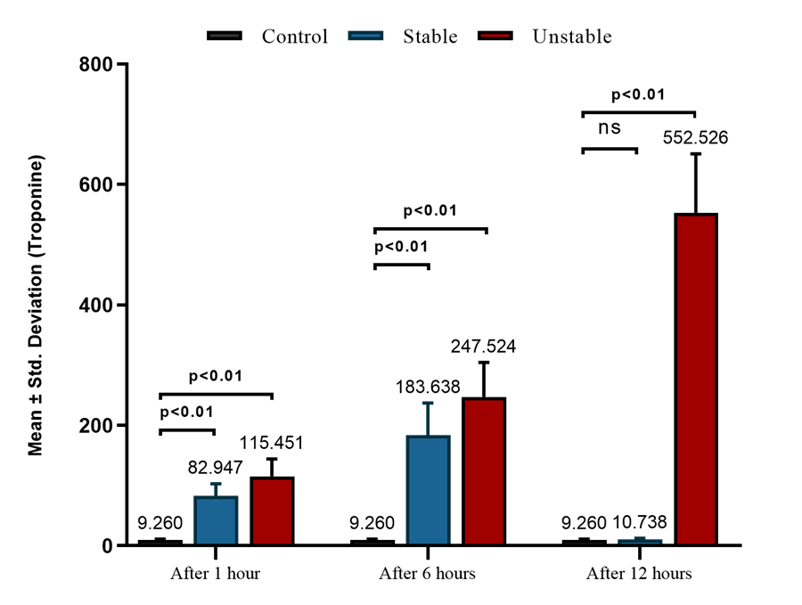
Figure( 4-8): The Comparison of the Troponin level Over Time Within Each Group according to the stability group.

Figure (4- 9) shows the results acquired for serum visfatin levels in patients groups with control group, raise significantly (p≤0.01) in visfatin at three different time points(each 5 hour), in stable and unstable type of angina compared with control group .
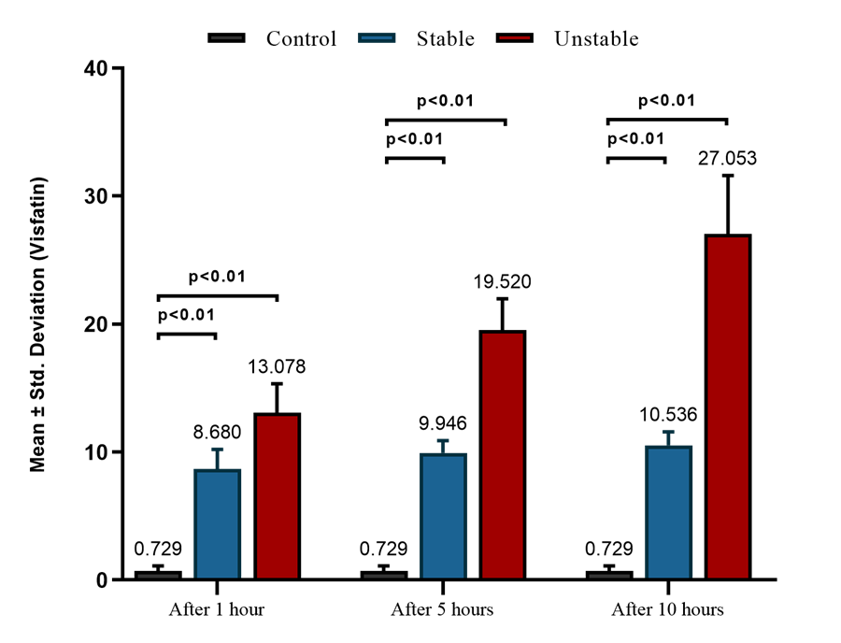
Figure (4-9): The Comparison of the Visfatin level Over Time Within Each Group according to the stability group.
Figure (4- 10 ) shows the results acquired for serum ACE levels in patients groups with control group, and show the elevation significantly (p≤0.01) in ACE levels in ( 1 and 5 hour) and decrease significantly (p≤0.01) in (10 hour) of patients with stable angina in comparison to control , increase significantly (p≤0.01) in ACE levels at( Each Time Point ) of patients with unstable angina in comparison to control group.
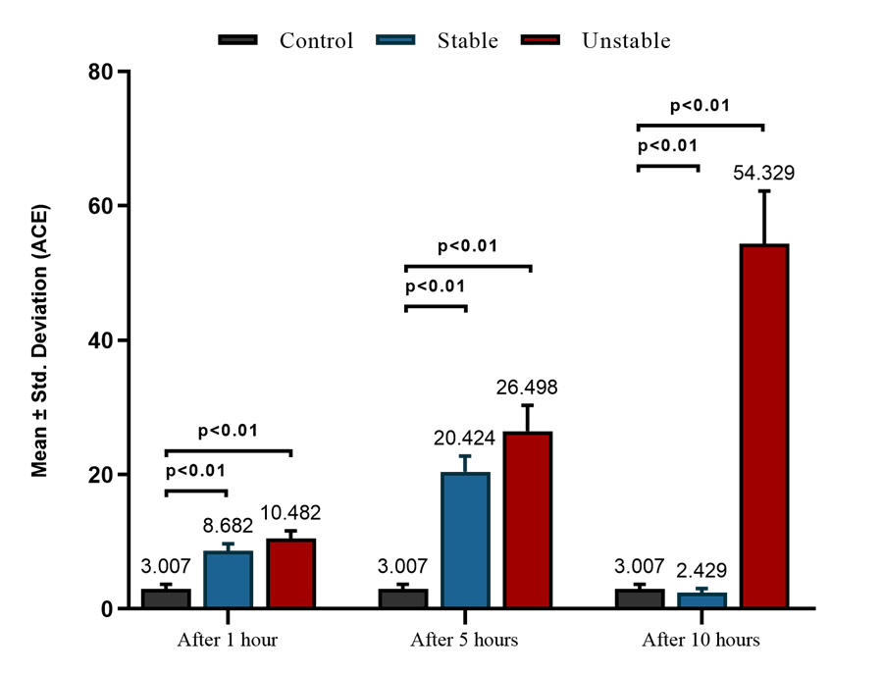
Figure( 4-10): The Comparison of the ACE level Over Time Within Each Group according to the stability group.

Figure (4- 11 ) appearances the results acquired for serum PR3 levels in patients groups with control group, and show the elevation significantly (p≤0.01) in PR3levels in ( 1 and 5 hour) and decrease significantly (p≤0.01) in (10 hour) of patients with stable angina in comparison to control , increase significantly (p≤0.01) in PR3levels at( Each Time Point ) of patients with unstable angina in comparison to control group.
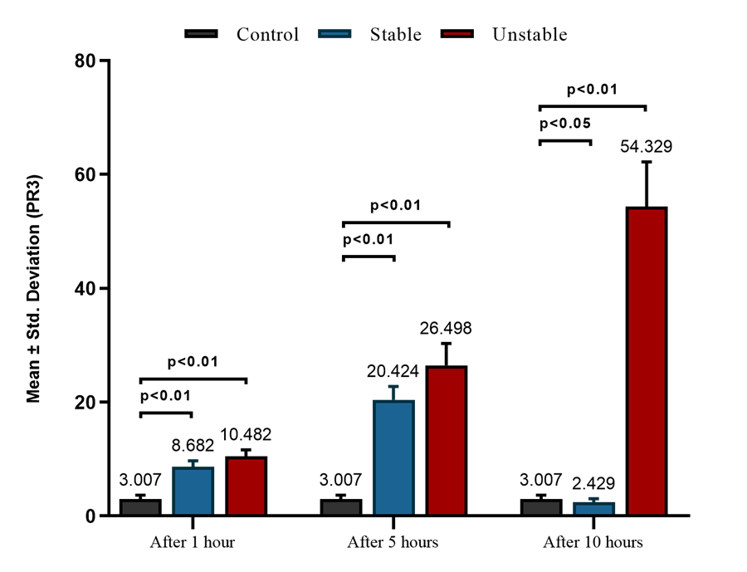
Figure( 4-11): The Comparison of the PR3 level Over Time Within Each Group according to the stability group.

Figure (4- 12 ) shows the results rise for TC,TG and LDL level s in patients groups with control group, according to the type of angina , escalation significantly (p≤0.01) in TC,TG and LDL levels of patients with stable and unstable angina in comparison to control group.
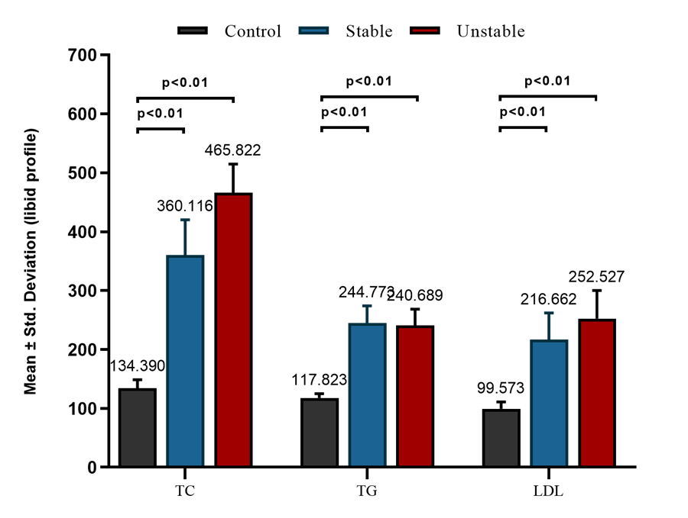
Figure (4-12): The Comparison between lipid profile level according to the stability group.
Correlation
In table (4-15) shows a significant a negative correlation between Visfatin with PR3 and Troponin levels (at different times) and significant a positive correlation between ACE levels, and shows a significant a positive correlation between ACE with PR3 levels ( After 5 hours ) , a significant a negative correlation ( After 10 hours) and a significant a positive correlation between ACE with Troponin levels , significant a positive correlation between PR3 and Troponin levels ( In 1 hour).
Table (4-15): Patients Correlation Coefficient Among Parameters According to stability group Status (Stable group)
Parameter | Time | Value | ACE |  |  | PR3 |  |  | Troponin
Parameter | Time | Value | In 1 hour | After 5 hours | After 10 hours | In 1 hour | After 5 hours | After 10 hours | In 1 hour | After 6 hours | After 12 hours
Visfatin | In 1 hour | R. value | .042 | .130 | .221 | -.311* | .018 | -.149 | -.110 | .150 | -.146
Visfatin | In 1 hour | P. value | .784 | .395 | .144 | .037 | .909 | .327 | .473 | .327 | .340
Visfatin | After 5 hours | R. value | .125 | .171 | -.058 | -.285 | .202 | -.033 | -.434** | -.140 | .072
Visfatin | After 5 hours | P. value | .412 | .261 | .707 | .058 | .183 | .827 | .003 | .359 | .639
Visfatin | After 10 hours | R. value | -.154 | -.176 | -.085 | .022 | -.021 | .100 | .046 | -.339* | -.019
Visfatin | After 10 hours | P. value | .313 | .247 | .578 | .884 | .892 | .515 | .765 | .023 | .903
ACE | In 1 hour | R. value | 1 | .437** | .376* | -.293 | .073 | .047 | -.130 | -.119 | .094
ACE | In 1 hour | P. value |  | .003 | .011 | .051 | .633 | .761 | .396 | .436 | .541
ACE | After 5 hours | R. value |  | 1.000 | .007 | -.100 | .441** | -.095 | -.008 | .353* | .044
ACE | After 5 hours | P. value |  |  | .966 | .512 | .002 | .533 | .956 | .017 | .775
ACE | After 10 hours | R. value |  |  | 1 | -.253 | -.322* | -.176 | -.160 | -.189 | .191
ACE | After 10 hours | P. value |  |  |  | .094 | .031 | .247 | .294 | .214 | .210
RP3 | In 1 hour | R. value |  |  |  | 1 | .039 | .010 | .537** | .251 | .253
RP3 | In 1 hour | P. value |  |  |  |  | .798 | .947 | .000 | .097 | .094
RP3 | After 5 hours | R. value |  |  |  |  | 1.000 | .132 | .168 | .178 | .037
RP3 | After 5 hours | P. value |  |  |  |  |  | .388 | .270 | .242 | .811
RP3 | After 10 hours | R. value |  |  |  |  |  | 1.000 | .055 | .040 | -.247
RP3 | After 10 hours | P. value |  |  |  |  |  |  | .718 | .793 | .102

R- = Negative correlation
R + = Positive correlation
** Correlation is significant at (p≤ 0.01)
* Correlation is significant at (p≤ 0.05)

In table (4-16) demonstrations a significant positive correlation between visfatin and TG levels( In 1 hour) and displays a significant negative correlation between PR3 with TC levels (After 5 hours).
Table(4-16): Patients Correlation Coefficient Among Parameters According to stability group Status (Stable group).
Parameters | Time | Value | TC | TG | LDL
Visfatin | In 1 hour | R. value | -.130 | .315* | -.162
Visfatin | In 1 hour | P. value | .395 | .035 | .287
Visfatin | After 5 hours | R. value | .161 | -.169 | .019
Visfatin | After 5 hours | P. value | .292 | .267 | .903
Visfatin | After 10 hours | R. value | .015 | -.197 | -.143
Visfatin | After 10 hours | P. value | .924 | .195 | .348
ACE | After 1 hour | R. value | .196 | -.062 | .052
ACE | After 1 hour | P. value | .196 | .687 | .733
ACE | After 5 hours | R. value | -.266 | .104 | .258
ACE | After 5 hours | P. value | .078 | .495 | .088
ACE | After 10 hours | R. value | .148 | .219 | -.216
ACE | After 10 hours | P. value | .331 | .148 | .154
PR3 | After 1 hour | R. value | -.108 | -.095 | -.087
PR3 | After 1 hour | P. value | .478 | .536 | .568
PR3 | After 5 hours | R. value | -.308* | -.071 | -.264
PR3 | After 5 hours | P. value | .040 | .644 | .080
PR3 | After 10 hours | R. value | -.028 | -.231 | -.105
PR3 | After 10 hours | P. value | .854 | .126 | .492
Troponin | After 1 hour | R. value | -.059 | .071 | -.129
Troponin | After 1 hour | P. value | .701 | .643 | .399
Troponin | After 6 hours | R. value | -.228 | .209 | .097
Troponin | After 6 hours | P. value | .132 | .169 | .525
Troponin | After 12 hours | R. value | .087 | -.168 | -.148
Troponin | After 12 hours | P. value | .570 | .271 | .333

R- = Negative correlation
R + = Positive correlation
** Correlation is significant at( p≤0.01)
* Correlation is significant at( p≤0.05)

Table (4-17) displays a significant negative correlation between Visfatin with GPX-1(In 1 hour) and a significant positive correlation between PR3 with 4-HNE levels (In 1 hour) and with GPX-1(After 10 hours) and shows a significant negative correlation with WBC levels (After 10 hours), a significant negative correlation between Troponin with GPX-1(In 1 hour).
Table (4-17): Patients Correlation Coefficient Among Parameters According to stability group Status (Stable group).
Parameters | Time | Value | WBC | GPX-1 | 4-HNE
Visfatin | In 1 hour | R. value | -.173 | -.352* | -.283
Visfatin | In 1 hour | P. value | .257 | .018 | .060
Visfatin | After 5 hours | R. value | .021 | .171 | .105
Visfatin | After 5 hours | P. value | .891 | .262 | .492
Visfatin | After 10 hours | R. value | -.050 | .076 | -.110
Visfatin | After 10 hours | P. value | .745 | .619 | .473
ACE | In 1 hour | R. value | .126 | .042 | .077
ACE | In 1 hour | P. value | .411 | .784 | .615
ACE | After 5 hours | R. value | .251 | -.206 | -.041
ACE | After 5 hours | P. value | .097 | .176 | .791
ACE | After 10 hours | R. value | .161 | -.076 | -.166
ACE | After 10 hours | P. value | .289 | .621 | .276
PR3 | In 1 hour | R. value | .044 | -.143 | .353*
PR3 | In 1 hour | P. value | .776 | .350 | .017
PR3 | After 5 hours | R. value | -.113 | -.106 | .087
PR3 | After 5 hours | P. value | .461 | .489 | .572
PR3 | After 10 hours | R. value | -.348* | .445** | -.108
PR3 | After 10 hours | P. value | .019 | .002 | .481
Troponin | In 1 hour | R. value | .024 | -.335* | .197
Troponin | In 1 hour | P. value | .877 | .025 | .195
Troponin | After 6 hours | R. value | .168 | -.183 | .208
Troponin | After 6 hours | P. value | .271 | .229 | .171
Troponin | After 12 hours | R. value | .082 | -.041 | .151
Troponin | After 12 hours | P. value | .592 | .787 | .322
R- = Negative correlation
R + = Positive correlation
** Correlation is significant at( p≤0.01)
* Correlation is significant at( p≤0.05)

In table (4-18) shows a significant a positive correlation between Visfatin with ACE,PR3 and Troponin (at different times),and shows a significant negative correlation between ACE with PR3, a significant positive correlation with troponin levels (at different times),and a significant positive correlation between PR3 with troponin levels (After 10 hours).
Table (4-18): Patients Correlation Coefficient Among Parameters According to stability group Status (Unstable group).

Parameters | Time | Value | ACE |  |  | PR3 |  |  | Troponin
Parameters | Time | Value | After 1 hour | After 5 hours | After 10 hours | After 1 hour | After 5 hours | After 10 hours | After 1 hour | After 6 hours | After 12 hours
Visfatin | In 1 hour | R. value | .002 | .192 | .103 | .045 | -.002 | .133 | .432** | .285 | .131
Visfatin | In 1 hour | P. value | .989 | .208 | .501 | .770 | .992 | .385 | .003 | .057 | .391
Visfatin | After 5 hours | R. value | .185 | .407** | -.026 | -.481** | .112 | -.103 | -.098 | .212 | .191
Visfatin | After 5 hours | P. value | .222 | .006 | .866 | .001 | .464 | .501 | .520 | .161 | .208
Visfatin | After 10 hours | R. value | -.172 | .425** | .190 | .041 | .073 | -.028 | .092 | .382** | .356*
Visfatin | After 10 hours | P. value | .259 | .004 | .210 | .789 | .636 | .855 | .549 | .010 | .016
ACE | In 1 hour | R. value | 1 | -.263 | -.055 | -.117 | -.295* | -.098 | -.033 | .320* | .138
ACE | In 1 hour | P. value |  | .081 | .718 | .444 | .049 | .522 | .831 | .032 | .366
ACE | After 5 hours | R. value |  | 1 | .076 | -.153 | -.198 | .120 | .231 | .115 | .297*
ACE | After 5 hours | P. value |  |  | .622 | .315 | .193 | .432 | .127 | .453 | .048
ACE | After 10 hours | R. value |  |  | 1.000 | .192 | -.050 | .275 | .046 | .152 | .434**
ACE | After 10 hours | P. value |  |  |  | .205 | .743 | .067 | .762 | .319 | .003
RP3 | In 1 hour | R. value |  |  |  | 1.000 | -.206 | .255 | .218 | .049 | .018
RP3 | In 1 hour | P. value |  |  |  |  | .175 | .090 | .150 | .749 | .908
RP3 | After 5 hours | R. value |  |  |  |  | 1.000 | -.016 | .087 | -.010 | -.143
RP3 | After 5 hours | P. value |  |  |  |  |  | .919 | .569 | .948 | .349
RP3 | After 10 hours | R. value |  |  |  |  |  | 1.000 | .396** | -.055 | .101
RP3 | After 10 hours | P. value |  |  |  |  |  |  | .007 | .719 | .509
R- = Negative correlation
R + = Positive correlation
** Correlation is significant at( p≤0.01)
* Correlation is significant at( p≤0.05)

Table (4-19) displays a significant positive correlation between Visfatin and ACE with TG, a significant positive correlation between PR3 and LDL(at different times).
Table (4-19): Patients Correlation Coefficient Among Parameters According to stability group Status (Unstable group).
Parameters | Time | Value | TC | TG | LDL
Visfatin | After 1 hour | R. value | -.102 | .187 | .139
Visfatin | After 1 hour | P. value | .504 | .219 | .363
Visfatin | After 5 hours | R. value | -.076 | .087 | .055
Visfatin | After 5 hours | P. value | .621 | .569 | .720
Visfatin | After 10 hours | R. value | .050 | .511** | .263
Visfatin | After 10 hours | P. value | .745 | .000 | .081
ACE | After 1 hour | R. value | -.181 | -.064 | .085
ACE | After 1 hour | P. value | .233 | .676 | .581
ACE | After 5 hours | R. value | .205 | .515** | .079
ACE | After 5 hours | P. value | .177 | .000 | .604
ACE | After 10 hours | R. value | .099 | .001 | .212
ACE | After 10 hours | P. value | .519 | .994 | .161
PR3 | After 1 hour | R. value | -.269 | .024 | -.056
PR3 | After 1 hour | P. value | .073 | .878 | .716
PR3 | After 5 hours | R. value | -.175 | .033 | -.177
PR3 | After 5 hours | P. value | .251 | .829 | .244
PR3 | After 10 hours | R. value | .246 | -.002 | .314*
PR3 | After 10 hours | P. value | .103 | .988 | .036
Troponin | After 1 hour | R. value | .155 | .176 | .134
Troponin | After 1 hour | P. value | .308 | .248 | .382
Troponin | After 6 hours | R. value | -.274 | .250 | .171
Troponin | After 6 hours | P. value | .068 | .098 | .261
Troponin | After 12 hours | R. value | -.004 | -.003 | .147
Troponin | After 12 hours | P. value | .979 | .986 | .336

R- = Negative correlation
R + = Positive correlation
** Correlation is significant at( p≤0.01)
* Correlation is significant at( p≤0.05)

In table (4-20) demonstrations a significant negative correlation between Visfatin and Troponin with WBC , a significant positive correlation between PR3 with 4-HNE( In 1 hour ).
Table (4-20): Patients Correlation Coefficient Among Biomarkers According to stability group Status (Unstable group).
Parameters | Time | Value | WBC | GPX-1 | 4-HNE
Visfatin | In 1 hour | R. value | -.437** | -.155 | .110
Visfatin | In 1 hour | P. value | .003 | .308 | .471
Visfatin | After 5 hours | R. value | .043 | -.042 | .134
Visfatin | After 5 hours | P. value | .778 | .782 | .380
Visfatin | After 10 hours | R. value | -.066 | -.104 | .174
Visfatin | After 10 hours | P. value | .668 | .495 | .252
ACE | After 1 hour | R. value | .036 | -.001 | .025
ACE | After 1 hour | P. value | .816 | .995 | .872
ACE | After 5 hours | R. value | -.006 | -.081 | -.150
ACE | After 5 hours | P. value | .967 | .596 | .327
ACE | After 10 hours | R. value | -.114 | .009 | .139
ACE | After 10 hours | P. value | .456 | .951 | .362
PR3 | After 1 hour | R. value | -.157 | .258 | .321*
PR3 | After 1 hour | P. value | .301 | .086 | .032
PR3 | After 5 hours | R. value | -.102 | -.100 | -.152
PR3 | After 5 hours | P. value | .505 | .515 | .320
PR3 | After 10 hours | R. value | -.154 | -.026 | -.029
PR3 | After 10 hours | P. value | .312 | .865 | .851
Troponin | After 1 hour | R. value | -.420** | .148 | -.079
Troponin | After 1 hour | P. value | .004 | .331 | .606
Troponin | After 6 hours | R. value | -.102 | -.244 | .254
Troponin | After 6 hours | P. value | .505 | .107 | .092
Troponin | After 12 hours | R. value | -.162 | -.182 | .260
Troponin | After 12 hours | P. value | .287 | .232 | .084
R- = Negative correlation
R + = Positive correlation
** Correlation is significant at( p≤0.01)
* Correlation is significant at( p≤0.05)

Chapter 5
Discussion

5-1. The Levels of research biomarkers in patients groups and control group at three different time points.
In this study and according to the results witch acquired in tables (4-1 , 4-2 , 4-3 , 4-4) we observed increase significantly (P≤ 0.01) in Troponin, visfatin , ACE , PR3, WBC and 4-HNE levels and the results shows decrease significantly (P≤ 0.01) in GPX-1 levels, this result may be induce by oxidative stress that results by smoking over load ,excess out put of hydrogen peroxide (H2O2) and superoxide (O-2) that responding to direct impact on activity of DNA , proteins and fats , that due to atherosclerosis Nicotine causes oxidation of LDL-c in Rats ,It is response of low antioxidants levels, the chemical substances that found in cigarette smoke due to dysfunction of liver and decrease liver activity in remove the toxins from the body and that lead to raise levels of TC and LDL-concentration and that may be by over smoking due to hyperlipidemia by change in (Hydroxyle -3-methylglutary- co enzyme A(HMG-Co A) reductase activity and dysfunction of cholesterol esters and decrease in lipoprotein lipase activity and all that lead to rise in free fatty acids in blood (),excess out put of ferry radicals response to excess tumar necrosis factors (TNF-α)
and interleukin (IL-IB) which lead to raise levels of cholesterogenic enzyme such as HMG-Co A reductase and diminution levels of α- cholesterol – 17 hydroxylase that in charge of cholesterol catabolism in liver , and by oxidative stress that results form smoking over load may because of stress of endoplasmic reticulum and rise in gene expression of strole on endoplasmic reticulum membrane and that due to height levels of TC and TG . and the results display high levels of LDL in patients groups and control group and this results may be induce by (hypersensitivity) of LDL-receptors in blood vessels to collection of lipoproteins in serum and result high rate of LDL in serum ()hyperlipidemia due to decrease or stooped blood flow in the arteries and blood vessel blockage which leads to stopping blood flow to tissues and a situation (hypoxia) occurs by oxidative stress , hyperlipidemia and hypoxia lead to damage in epithelial cells of blood vessels in (heart and kidney ) which causes increased leakage of Troponin and ACE in blood and raise neutrophils outflow from epithelial of damaged cells and this causes higher levels of PR3 and visfatin in blood The results discerned a rise (p ≤ 0.01) in 4-HNE ,WBC ,and decease (p ≤ 0.01) in GPX-1 levels in patients groups and control group that may be by the consumption of GPX-1 in the body result of occurrence oxidative stress and generation of large amount of reactive oxygen species by over load of smoking , GPX-1 help to protect the cells from the damage by oxidative stress and the rise in reactive oxygen species due to decrease in GPX-1and increase 4-HNE and WBC levels.

5-2: The Comparison between research parameters levels at Each Time Point Separately according to the type of angina.
In tables (4-5 , 4-6 , 4-7 , 4-8) and figures (4-4 . 4-8 , 4-9 , 4-10 , 4-11 , 4-12) the results appearance a return markers levels to normal state ,(in patients with stable angina) and the reason may be due to a minor injury in the heart muscle, or the formation of a small clot ,inflammation and the effect of oxidative stress are minimal the results also showed a continued rise in the levels of parameters at (Each Time Point in patients with unstable angina), this may be by the possibility of injury with cardiomyopathy , congestive heart failure , myocarditis and heart attack and over load oxidative stress and increased release of free radicals which leads to cells damage .

5-3: The Comparison between research parameters levels at Each Time Point Separately according to the age .
In tables (4-11 , 4-12 , 4-13 , 4-14) the results revealed the effect of age on parameters , we notice an rise in the state of oxidative stress and hyperlipidemia with the progress of age and over load oxidative stress and increased release of free radicals which leads to cells damage and fat accumulation in blood vessels and this increase the risk of heart disease .

5-4: The correlation between research parameters levels at Each Time Point Separately according to the stability groups .
The results show in tables (4-15 , 4-16 , 4-17 , 4-18 , 4-19 , 4-20) there is a positive or negative correlation between the parameters depending on severity of oxidative stress and hyperlipidemia by overload smoking and clot buildup in blood vessels , the time factor displayed an effect on the correlation between the parameters.

References

References
- O'Dowd, B. F., Heiber, M., Chan, A., et al. (1993). A human gene that shows identity with the gene encoding the angiotensin receptor is located on chromosome 11. *Gene, 136*(1-2), 355-360.
- Scherer, P. E., Williams, S., Fogliano, M., Baldini, G., & Lodish, H. F. (1995). A novel serum protein similar to C1q, produced exclusively in adipocytes. *Journal of Biological Chemistry, 270*(45), 26746-26749.
- Heidenreich, P. A., Bozkurt, B., Aguilar, D., et al. (2021). 2021 ACC/AHA key data elements and definitions for heart failure: A report of the American College of Cardiology/American Heart Association Task Force on Clinical Data Standards. *Circulation, 143*(5), e35-e71. https://doi.org/10.1161/CIR.0000000000000931
- Yancy, C. W., Jessup, M., Bozkurt, B., et al. (2020). 2017 ACC/AHA/HFSA Focused Update of the 2013 ACCF/AHA Guideline for the Management of Heart Failure: A report of the American College of Cardiology/American Heart Association Task Force on Clinical Practice Guidelines and the Heart Failure Society of America. *Circulation, 136*(6), e137-e161. https://doi.org/10.1161/CIR.0000000000000509
- Japp, A. G., Cruden, N. L., Barnes, G., et al. (2010). Acute cardiovascular effects of apelin in humans: Potential role in patients with chronic heart failure. *Circulation, 121*(16), 1818-1827.
- Fuster, V., & Kovacic, J. C. (2020). Acute coronary syndromes: Pathology, diagnosis, genetics, prevention, and treatment. *Circulation Research, 126*(12), 1677-1699. https://doi.org/10.1161/CIRCRESAHA.119.315912
- Crea, F., & Libby, P. (2020). Acute coronary syndromes: The way forward from mechanisms to precision treatment. *Circulation, 141*(14), 1153-1166. https://doi.org/10.1161/CIRCULATIONAHA.119.042573
- Gheorghiade, M., & Pang, P. S. (2020). Acute heart failure syndromes. *Journal of the American College of Cardiology, 75*(15), 1818-1833. https://doi.org/10.1016/j.jacc.2020.02.025
- Fujiki, S., Watanabe, H., Obata, H., et al. (2021). Adipokines in patients with heart failure under rehabilitation. *Acta Biomedica, 92*(3), e2021195.
- Ingelsson, E., Risérus, U., Berne, C., et al. (2006). Adiponectin and risk of congestive heart failure. *JAMA, 295*(15), 1769-1774.
- Mado, H., Szczurek, W., Gąsior, M., & Szyguła-Jurkiewicz, B. (2020). Adiponectin in heart failure. *Future Cardiology, 17*(4), 757-764.
- Hu, E., Liang, P., & Spiegelman, B. M. (1996). AdipoQ is a novel adipose-specific gene dysregulated in obesity. *Journal of Biological Chemistry, 271*(18), 10697-10703.
- Solomon, S. D., McMurray, J. J. V., Anand, I. S., et al. (2020). Angiotensin–neprilysin inhibition in heart failure with preserved ejection fraction. *New England Journal of Medicine, 381*(17), 1609-1620. https://doi.org/10.1056/NEJMoa1903825
- Perjes, A., Skoumal, R., Tenhunen, O., et al. (2014). Apelin increases cardiac contractility via protein kinase Cε- and extracellular signal-regulated kinase-dependent mechanisms. *PLoS One, 9*(4), e93473.
- Zhong, S., Guo, H., Wang, H., et al. (2020). Apelin-13 alleviated cardiac fibrosis via inhibiting the PI3K/Akt pathway to attenuate oxidative stress in rats with myocardial infarction-induced heart failure. *Bioscience Reports, 40*(4), BSR20200040.
- Menzel, J., di Giuseppe, R., Biemann, R., et al. (2017). Association between chemerin, omentin-1 and risk of heart failure in the population-based EPIC-Potsdam study. *Scientific Reports, 7*(1), 14171.
- Garg, P. K., O'Neal, W. T., & Chen, L. Y. (2020). Biomarkers in heart failure: A focus on natriuretic peptides. *Heart Failure Clinics, 16*(1), 1-12. https://doi.org/10.1016/j.hfc.2019.08.001
- Voors, A. A., & van der Meer, P. (2020). Biomarkers in heart failure: From research to clinical practice. *European Journal of Heart Failure, 22*(2), 214-223. https://doi.org/10.1002/ejhf.1706
- Teerlink, J. R., Diaz, R., Felker, G. M., et al. (2020). Cardiac myosin activation with omecamtiv mecarbil in systolic heart failure. *New England Journal of Medicine, 383*(8), 711-721. https://doi.org/10.1056/NEJMoa2025797
- Hill, J. A., & Olson, E. N. (2020). Cardiac plasticity. *New England Journal of Medicine, 382*(22), 2128-2140. https://doi.org/10.1056/NEJMra1906186
- Zannad, F., & Rossignol, P. (2020). Cardiorenal syndrome revisited. *Circulation, 141*(8), 659-671. https://doi.org/10.1161/CIRCULATIONAHA.119.043299
- Maeda, K., Okubo, K., Shimomura, I., Funahashi, T., Matsuzawa, Y., & Matsubara, K. (1996). cDNA cloning and expression of a novel adipose specific collagen-like factor, apM1 (AdiPose Most abundant Gene transcript 1). *Biochemical and Biophysical Research Communications, 221*(2), 286-289.
- İnci, S., Aksan, G., & Doğan, P. (2016). Chemerin as an independent predictor of cardiovascular event risk. *Therapeutic Advances in Endocrinology and Metabolism, 7*(2), 57-68.
- Bozaoglu, K., Bolton, K., McMillan, J., et al. (2007). Chemerin is a novel adipokine associated with obesity and metabolic syndrome. *Endocrinology, 148*(10), 4687-4694.
- Roh, S. G., Song, S. H., Choi, K. C., et al. (2007). Chemerin—a new adipokine that modulates adipogenesis via its own receptor. *Biochemical and Biophysical Research Communications, 362*(4), 1013-1018.
- George, J., Patal, S., Wexler, D., et al. (2006). Circulating adiponectin concentrations in patients with congestive heart failure. *Heart, 92*(10), 1420-1424.
- Bhatt, D. L., Lopes, R. D., & Harrington, R. A. (2020). Diagnosis and treatment of acute coronary syndromes: A review. *JAMA, 324*(13), 1325-1336. https://doi.org/10.1001/jama.2020.14243
- Patel, S. D., Rajala, M. W., Rossetti, L., Scherer, P. E., & Shapiro, L. (2004). Disulfide-dependent multimeric assembly of resistin family hormones. *Science, 304*(5674), 1154-1158.
- Pang, H., Han, B., Yu, T., & Zong, Z. (2014). Effect of apelin on the cardiac hemodynamics in hypertensive rats with heart failure. *International Journal of Molecular Medicine, 34*(3), 756-764.
- Knuuti, J., Wijns, W., Saraste, A., et al. (2020). 2019 ESC Guidelines for the diagnosis and management of chronic coronary syndromes. *European Heart Journal, 41*(3), 407-477. https://doi.org/10.1093/eurheartj/ehz425
- Ponikowski, P., Voors, A. A., Anker, S. D., et al. (2020). 2016 ESC Guidelines for the diagnosis and treatment of acute and chronic heart failure. *European Heart Journal, 37*(27), 2129-2200. https://doi.org/10.1093/eurheartj/ehw128
- Van Berendoncks, A. M., Garnier, A., Beckers, P., et al. (2010). Functional adiponectin resistance at the level of the skeletal muscle in mild to moderate chronic heart failure. *Circulation: Heart Failure, 3*(2), 185-194.
- Benjamin, E. J., Muntner, P., Alonso, A., et al. (2019). Heart disease and stroke statistics—2019 update: A report from the American Heart Association. *Circulation, 139*(10), e56-e528. https://doi.org/10.1161/CIR.0000000000000659
- Go, A. S., Mozaffarian, D., Roger, V. L., et al. (2020). Heart disease and stroke statistics—2020 update: A report from the American Heart Association. *Circulation, 141*(9), e139-e596. https://doi.org/10.1161/CIR.0000000000000757
- Virani, S. S., Alonso, A., Aparicio, H. J., et al. (2021). Heart disease and stroke statistics—2021 update: A report from the American Heart Association. *Circulation, 143*(8), e254-e743. https://doi.org/10.1161/CIR.0000000000000950
- Taylor, A. L., & Ziesche, S. (2020). Heart failure in African Americans: Pathophysiology and treatment. *Journal of Cardiac Failure, 26*(1), 1-10. https://doi.org/10.1016/j.cardfail.2019.10.009
- Butrous, H., & Hummel, S. L. (2016). Heart failure in older adults. *Canadian Journal of Cardiology, 32*(9), 1140-1147.
- Rosano, G. M. C., Vitale, C., & Seferovic, P. (2020). Heart failure in patients with diabetes mellitus. *Cardiac Failure Review, 6*(1), 33-39. https://doi.org/10.15420/cfr.2019.12
- Shah, S. J., & Gheorghiade, M. (2020). Heart failure with preserved ejection fraction: Mechanisms and therapeutic approaches. *Circulation, 141*(11), 877-879. https://doi.org/10.1161/CIRCULATIONAHA.119.044589
- Murphy, S. P., Ibrahim, N. E., & Januzzi, J. L. (2020). Heart failure with reduced ejection fraction: A review. *JAMA, 324*(5), 488-504. https://doi.org/10.1001/jama.2020.10262
- Braunwald, E. (2013). Heart failure. *JACC: Heart Failure, 1*(1), 1-20.
- Kamimura, D., Suzuki, T., Wang, W., et al. (2018). Higher plasma leptin levels are associated with reduced left ventricular mass and left ventricular diastolic stiffness in black women: Insights from the Genetic Epidemiology Network of Arteriopathy (GENOA) study. *Hypertension Research, 41*(8), 629-638.
- McMurray, J. J. V., & Packer, M. (2020). How should we sequence the treatments for heart failure and a reduced ejection fraction? A redefinition of evidence-based medicine. *Circulation, 141*(11), 874-876. https://doi.org/10.1161/CIRCULATIONAHA.119.044589
- Schwartz, D. R., Briggs, E. R., Qatanani, M., et al. (2013). Human resistin in chemotherapy-induced heart failure in humanized male mice and in women treated for breast cancer. *Endocrinology, 154*(11), 4206-4214.
- Leyva, F., Anker, S. D., Egerer, K., Stevenson, J. C., Kox, W. J., & Coats, A. J. (1998). Hyperleptinaemia in chronic heart failure: Relationships with insulin. *European Heart Journal, 19*(10), 1547-1551.
- Yang, R. Z., Lee, M. J., Hu, H., et al. (2006). Identification of omentin as a novel depot-specific adipokine in human adipose tissue: Possible role in modulating insulin action. *American Journal of Physiology-Endocrinology and Metabolism, 290*(6), E1253-E1261.
- Fain, J. N., Sacks, H. S., Buehrer, B., et al. (2008). Identification of omentin mRNA in human epicardial adipose tissue: Comparison to omentin in subcutaneous, internal mammary artery periadventitial and visceral abdominal depots. *International Journal of Obesity, 32*(5), 810-815.
- Gargalovic, P., Wong, P., Onorato, J., et al. (2021). In vitro and in vivo evaluation of a small-molecule APJ (apelin receptor) agonist, BMS-986224, as a potential treatment for heart failure. *Circulation: Heart Failure, 14*(3), e007351.
- Chavarria, N., Kato, T. S., Khan, R., et al. (2012). Increased levels of retinol binding protein 4 in patients with advanced heart failure correct after hemodynamic improvement through ventricular assist device placement. *Circulation Journal, 76*(9), 2148-2152.
- Libby, P., & Lüscher, T. (2020). Inflammation and cardiovascular disease: Mechanisms and therapeutic approaches. *European Heart Journal, 41*(31), 2973-2979. https://doi.org/10.1093/eurheartj/ehaa279
- Gregor, M. F., & Hotamisligil, G. S. (2011). Inflammatory mechanisms in obesity. *Annual Review of Immunology, 29*, 415-445.
- Shimada, Y. J. (2019). Is leptin protective against heart failure with preserved ejection fraction? A complex interrelationship among leptin, obesity, and left ventricular hypertrophy. *Hypertension Research, 42*(2), 141-142.
- Tatemoto, K., Hosoya, M., Habata, Y., et al. (1998). Isolation and characterization of a novel endogenous peptide ligand for the human APJ receptor. *Biochemical and Biophysical Research Communications, 251*(2), 471-476.
- Nakano, Y., Tobe, T., Choi-Miura, N. H., Mazda, T., & Tomita, M. (1996). Isolation and characterization of GBP28, a novel gelatin-binding protein purified from human plasma. *Journal of Biochemistry, 120*(4), 803-812.
- Elias, C. F., Lee, C., Kelly, J., et al. (1998). Leptin activates hypothalamic CART neurons projecting to the spinal cord. *Neuron, 21*(6), 1375-1385.
- Obradovic, M., Sudar-Milovanovic, E., Soskic, S., et al. (2021). Leptin and obesity: Role and clinical implication. *Frontiers in Endocrinology, 12*, 585887.
- Packer, M. (2018). Leptin-aldosterone-neprilysin axis: Identification of its distinctive role in the pathogenesis of the three phenotypes of heart failure in people with obesity. *Circulation, 137*(15), 1614-1631.
- Zhou, Y. T., Grayburn, P., Karim, A., et al. (2000). Lipotoxic heart disease in obese rats: Implications for human obesity. *Proceedings of the National Academy of Sciences, 97*(4), 1784-1789.
- Azad, N., & Lemay, G. (2014). Management of chronic heart failure in the older population. *Journal of Geriatric Cardiology, 11*(4), 329-337.
- Mann, D. L., & Felker, G. M. (2020). Mechanisms and models in heart failure: The translational path to precision medicine. *Circulation Research, 126*(12), 1646-1661. https://doi.org/10.1161/CIRCRESAHA.119.315939
- Ebong, I. A., Goff, D. C., Rodriguez, C. J., Chen, H., & Bertoni, A. G. (2014). Mechanisms of heart failure in obesity. *Obesity Research & Clinical Practice, 8*(6), e540-e548.
- Elgendy, I. Y., Mahtta, D., & Pepine, C. J. (2021). Medical therapy for heart failure caused by ischemic heart disease. *Circulation Research, 128*(10), 1524-1544. https://doi.org/10.1161/CIRCRESAHA.121.318163
- Pitkin, S. L., Maguire, J. J., Kuc, R. E., & Davenport, A. P. (2010). Modulation of the apelin/APJ system in heart failure and atherosclerosis in man. *British Journal of Pharmacology, 160*(7), 1785-1795.
- Fatima, S. S., Rehman, R., Baig, M., & Khan, T. A. (2014). New roles of the multidimensional adipokine: Chemerin. *Peptides, 62*, 15-20.
- Garten, A., Petzold, S., Barnikol-Oettler, A., et al. (2010). Nicotinamide phosphoribosyltransferase (NAMPT/PBEF/visfatin) is constitutively released from human hepatocytes. *Biochemical and Biophysical Research Communications, 391*(1), 376-381.
- Savic-Radojevic, A., Pljesa-Ercegovac, M., Matic, M., Simic, D., Radovanovic, S., & Simic, T. (2017). Novel biomarkers of heart failure. *Advances in Clinical Chemistry, 79*, 93-152.
- Alpert, M. A., Lavie, C. J., & Agrawal, H. (2020). Obesity and heart failure: Epidemiology, pathophysiology, and clinical management. *Journal of the American College of Cardiology, 75*(12), 1469-1482. https://doi.org/10.1016/j.jacc.2020.01.030
- Alpert, M. A., Lavie, C. J., Agrawal, H., Aggarwal, K. B., & Kumar, S. A. (2014). Obesity and heart failure: Epidemiology, pathophysiology, clinical manifestations, and management. *Translational Research, 164*(4), 345-356.
- Kenchaiah, S., Evans, J. C., Levy, D., et al. (2002). Obesity and the risk of heart failure. *New England Journal of Medicine, 347*(5), 305-313.
- Wong, C., & Marwick, T. H. (2007). Obesity cardiomyopathy: Pathogenesis and pathophysiology. *Nature Clinical Practice Cardiovascular Medicine, 4*(8), 436-443.
- Vincent, H. K., Powers, S. K., Stewart, D. J., Shanely, R. A., Demirel, H., & Naito, H. (1999). Obesity is associated with increased myocardial oxidative stress. *International Journal of Obesity, 23*(1), 67-74.
- Kistorp, C., Faber, J., Galatius, S., et al. (2005). Plasma adiponectin, body mass index, and mortality in patients with chronic heart failure. *Circulation, 112*(12), 1756-1762.
- Lieb, W., Sullivan, L. M., Harris, T. B., et al. (2009). Plasma leptin levels and incidence of heart failure, cardiovascular disease, and total mortality in elderly individuals. *Diabetes Care, 32*(4), 612-616.
- Majerczyk, M., Choręza, P., Mizia-Stec, K., et al. (2018). Plasma level of retinol-binding protein 4, N-terminal proBNP and renal function in older patients hospitalized for heart failure. *Cardiorenal Medicine, 8*(3), 237-248.
- Zhang, Y., Proenca, R., Maffei, M., Barone, M., Leopold, L., & Friedman, J. M. (1994). Positional cloning of the mouse obese gene and its human homologue. *Nature, 372*(6505), 425-432.
- Steppan, C. M., & Lazar, M. A. (2002). Resistin and obesity-associated insulin resistance. *Trends in Endocrinology and Metabolism, 13*(1), 18-23.
- Zhao, B., Bouchareb, R., & Lebeche, D. (2021). Resistin deletion protects against heart failure injury by targeting DNA damage response. *Cardiovascular Research, 118*(8), 1947-1963.
- Frankel, D. S., Vasan, R. S., D'Agostino, R. B., et al. (2009). Resistin, adiponectin, and risk of heart failure: The Framingham offspring study. *Journal of the American College of Cardiology, 53*(9), 754-762.
- Jamaluddin, M. S., Weakley, S. M., Yao, Q., & Chen, C. (2012). Resistin: Functional roles and therapeutic considerations for cardiovascular disease. *British Journal of Pharmacology, 165*(3), 622-632.
- Graham, T. E., Yang, Q., Bluher, M., et al. (2006). Retinol-binding protein 4 and insulin resistance in lean, obese, and diabetic subjects. *New England Journal of Medicine, 354*(24), 2552-2563.
- Blaner, W. S. (1989). Retinol-binding protein: The serum transport protein for vitamin A. *Endocrine Reviews, 10*(3), 308-316.
- Kanai, M., Raz, A., & Goodman, D. S. (1968). Retinol-binding protein: The transport protein for vitamin A in human plasma. *Journal of Clinical Investigation, 47*(9), 2025-2044.
- Skoczylas, A. (2009). Rola wisfatyny w patofizjologii człowieka [The role of visfatin in the pathophysiology of human]. *Wiadomości Lekarskie, 62*(3), 190-196.
- Lau, W. B., Ohashi, K., Wang, Y., et al. (2017). Role of adipokines in cardiovascular disease. *Circulation Journal, 81*(7), 920-928.
- Poetsch, M. S., Strano, A., & Guan, K. (2020). Role of leptin in cardiovascular diseases. *Frontiers in Endocrinology, 11*, 354.
- Zhou, X., Tao, Y., Chen, Y., Xu, W., Qian, Z., & Lu, X. (2019). Serum chemerin as a novel prognostic indicator in chronic heart failure. *Journal of the American Heart Association, 8*(15), e012091.
- Straburzyńska-Migaj, E., Pilaczyńska-Szcześniak, L., Nowak, A., Straburzyńska-Lupa, A., Sliwicka, E., & Grajek, S. (2012). Serum concentration of visfatin is decreased in patients with chronic heart failure. *Acta Biochimica Polonica, 59*(3), 339-343.
- Butler, J., Kalogeropoulos, A., Georgiopoulou, V., et al. (2009). Serum resistin concentrations and risk of new onset heart failure in older persons: The health, aging, and body composition (Health ABC) study. *Arteriosclerosis, Thrombosis, and Vascular Biology, 29*(7), 1144-1149.
- Takeishi, Y., Niizeki, T., Arimoto, T., et al. (2007). Serum resistin is associated with high risk in patients with congestive heart failure—a novel link between metabolic signals and heart failure. *Circulation Journal, 71*(4), 460-464.
- Yang, Q., Graham, T. E., Mody, N., et al. (2005). Serum retinol binding protein 4 contributes to insulin resistance in obesity and type 2 diabetes. *Nature, 436*(7049), 356-362.
- Li, X. Z., Zhang, K. Z., Yan, J. J., et al. (2020). Serum retinol-binding protein 4 as a predictor of cardiovascular events in elderly patients with chronic heart failure. *ESC Heart Failure, 7*(2), 542-550.
- Zhou, X., Chen, Y., Tao, Y., Zhang, W., Xu, W., & Lu, X. (2019). Serum vaspin as a predictor of adverse cardiac events in acute myocardial infarction. *Journal of the American Heart Association, 8*(2), e010934.
- Costford, S. R., Bajpeyi, S., Pasarica, M., et al. (2010). Skeletal muscle NAMPT is induced by exercise in humans. *American Journal of Physiology-Endocrinology and Metabolism, 298*(6), E117-E126.
- Daiber, A., Steven, S., Weber, A., et al. (2021). Targeting vascular (endothelial) dysfunction. *British Journal of Pharmacology, 178*(12), 2291-2314. https://doi.org/10.1111/bph.15299
- Nagpal, S., Patel, S., Jacobe, H., et al. (1997). Tazarotene-induced gene 2 (TIG2), a novel retinoid-responsive gene in skin. *Journal of Investigative Dermatology, 109*(1), 91-95.
- Chapman, N. A., Dupré, D. J., & Rainey, J. K. (2014). The apelin receptor: Physiology, pathology, cell signalling, and ligand modulation of a peptide-activated class A GPCR. *Biochemistry and Cell Biology, 92*(6), 431-440.
- Japp, A. G., & Newby, D. E. (2020). The apelin-APJ system in heart failure: Pathophysiologic relevance and therapeutic potential. *Biochemical Pharmacology, 178*, 113972. https://doi.org/10.1016/j.bcp.2020.113972
- Goidescu, C. M., & Vida-Simiti, L. A. (2015). The apelin-APJ system in the evolution of heart failure. *Clujul Medical, 88*(1), 3-8.
- Nanayakkara, G., Kariharan, T., Wang, L., Zhong, J., & Amin, R. (2012). The cardio-protective signaling and mechanisms of adiponectin. *American Journal of Cardiovascular Disease, 2*(4), 253-266.
- Ashley, E. A., Powers, J., Chen, M., et al. (2005). The endogenous peptide apelin potently improves cardiac contractility and reduces cardiac loading in vivo. *Cardiovascular Research, 65*(1), 73-82.
- Steppan, C. M., Bailey, S. T., Bhat, S., et al. (2001). The hormone resistin links obesity to diabetes. *Nature, 409*(6818), 307-312.
- Dessi-Fulgheri, P., Sarzani, R., & Rappelli, A. (1998). The natriuretic peptide system in obesity-related hypertension: New pathophysiological aspects. *Journal of Nephrology, 11*(6), 296-299.
- Packer, M. (2020). The neurohormonal hypothesis: A theory to explain the mechanism of disease progression in heart failure. *Journal of the American College of Cardiology, 75*(15), 1834-1847. https://doi.org/10.1016/j.jacc.2020.02.031
- Engeli, S., & Sharma, A. M. (2001). The renin-angiotensin system and natriuretic peptides in obesity-associated hypertension. *Journal of Molecular Medicine, 79*(1), 21-29.
- Chandrasekaran, B., Dar, O., & McDonagh, T. (2008). The role of apelin in cardiovascular function and heart failure. *European Journal of Heart Failure, 10*(8), 725-732.
- Dimova, R., & Tankova, T. (2015). The role of vaspin in the development of metabolic and glucose tolerance disorders and atherosclerosis. *BioMed Research International, 2015*, 823481.
- Shen, Q., Hiebert, J. B., Rahman, F. K., Krueger, K. J., Gupta, B., & Pierce, J. D. (2021). Understanding obesity-related high output heart failure and its implications. *International Journal of Heart Failure, 3*(3), 160-171.
- Bozkurt, B., Coats, A. J. S., Tsutsui, H., et al. (2021). Universal definition and classification of heart failure: A report of the Heart Failure Society of America, Heart Failure Association of the European Society of Cardiology, Japanese Heart Failure Society and Writing Committee of the Universal Definition of Heart Failure. *Journal of Cardiac Failure, 27*(4), 387-413. https://doi.org/10.1016/j.cardfail.2021.01.022
- Moursi, S. M., Ashour, W. M., & Elbelbesy, R. M. (2019). Vaspin improves experimental isoproterenol-induced heart failure in rats. *American Journal of Biomedical Sciences, 11*(3), 141-151.
- Wada, J. (2008). Vaspin: A novel serpin with insulin-sensitizing effects. *Expert Opinion on Investigational Drugs, 17*(3), 327-333.
- Hida, K., Wada, J., Eguchi, J., et al. (2005). Visceral adipose tissue-derived serine protease inhibitor: A unique insulin-sensitizing adipocytokine in obesity. *Proceedings of the National Academy of Sciences, 102*(30), 10610-10615.
- Fukuhara, A., Matsuda, M., Nishizawa, M., et al. (2005). Visfatin: A protein secreted by visceral fat that mimics the effects of insulin. *Science, 307*(5708), 426-430.
- Schmidt, M., Bøtker, H. E., Pedersen, L., & Sørensen, H. T. (2014). Young adulthood obesity and risk of acute coronary syndromes, stable angina pectoris, and congestive heart failure: A 36-year cohort study. *Annals of Epidemiology, 24*(5), 356-361.

Appendices

Appendix.1

Questionnaire for Participants
• Name: __________________________
• Age: __________________________
• Gender: __________________________
• Phone Number: __________________________
• Height: __________________________
• Weight: __________________________
• Chronic Disease: __________________________
• Stage of Disease:
• NAFLD: __________________________
• NASH: __________________________
• Cirrhosis: __________________________
• Lipid Profile:
• Cholesterol: __________________________
• Triglycerides: __________________________
• HDL: __________________________
• Liver Enzymes (AST/ALT): __________________________

Appendix.2

Measurement of Biomarkers
The DIRUI device automatically measures liver enzymes and lipid profiles.
A centrifuge is used to separate the blood sample, and the separated serum is placed into a Hitachi cup. The measurement is then performed by placing the cup in the appropriate location on the DIRUI dev.

الخلاصة

الخلفية العلمية :
تعد أمراض القلب والأوعية الدموية، وخاصة الذبحة الصدرية، من الأسباب الرئيسية للاعتلال والوفيات عالمياً. تهدف هذه الدراسة إلى تقييم مستويات إنزيم البروتيناز-3 (PR3)، الإنزيم المحول للأنجيوتنسين (ACE)، والفيسفاتين كواسمات حيوية محتملة للكشف المبكر عن الذبحة الصدرية لدى الذكور في محافظة كربلاء، العراق. ترتبط هذه الواسمات بالعمليات الالتهابية وإصابة الأوعية الدموية والتغيرات الأيضية التي تلعب دوراً رئيسياً في الإصابة بالذبحة الصدرية.
المنهجية :
أجريت الدراسة في مدينة الإمام الحسين الطبية ومركز جراحة القلب من أكتوبر 2024 إلى يناير 2025، وشملت120 مشاركاً من الذكور (90 مريضاً بالذبحة الصدرية: 45 ذبحة مستقرة و45 غير مستقرة، و30 شخصاً كمجموعة ضابطة).
  - جمع عينات الدم في أوقات مختلفة (1، 5، 6، 10، 12 ساعة)
  - قياس الواسمات الحيوية باستخدام تقنية ELISA
  - تحليل إحصائي لمقارنة النتائج بين المجموعات

النتائج الرئيسية :
- التروبونين : ارتفاع ملحوظ لدى مرضى الذبحة مقارنة بالضوابط و مستويات أعلى في الذبحة غير المستقرة وزيادة تدريجية مع الوقت
- الفيسفاتين ، ACE و PR3 : ارتفاع كبير لدى مرضى الذبحة ، و مستويات أعلى في الحالات غير المستقرة ، وزيادة تدريجية في الفيسفاتين وACE مع الوقت مع انخفاض طفيف في PR3 بعد ارتفاع أولي .
- الإجهاد التأكسدي والالتهاب : ارتفاع كريات الدم البيضاء و4-HNE مع انخفاض إنزيم GPX-1 المضاد للأكسدة.
- الدهون: ارتفاع الكوليسترول الكلي والدهون الثلاثية وLDL ، بالإضافة الى خلل أكثر شدة في الذبحة غير المستقرة .
- العلاقات الترابطية : ارتباط قوي بين الفيسفاتين، ACE، PR3 والتروبونين .

الاستنتاجات:
تُظهر الدراسة أن مستويات PR3 وACE والفيزفاتين مرتفعة بشكل ملحوظ لدى مرضى الذبحة الصدرية، لا سيما في حالات الذبحة غير المستقرة. ويمكن لهذه العلامات البيولوجية، إلى جانب التروبونين ومؤشرات الإجهاد التأكسدي والملف الدهني، أن تكون مؤشرات واعدة للكشف المبكر عن الذبحة الصدرية والتمييز بين أنواعها. وتشير النتائج إلى إمكانية دمج هذه العلامات البيولوجية في الممارسات السريرية لتحسين تشخيص الذبحة الصدرية وإدارتها، مما قد يسهم في تحقيق نتائج أفضل للمرضى. ويوصى بإجراء المزيد من الأبحاث للتحقق من هذه النتائج في مجموعات سكانية أوسع وأكثر تنوعًا، واستكشاف الآثار العلاجية المحتملة لتنظيم هذه العلامات البيولوجية.

Glutathione peroxidase 1
4-Hydroxynonenal
Angiotensin Converting Enzyme
Human Proteinase 3
Horseradish peroxidase

